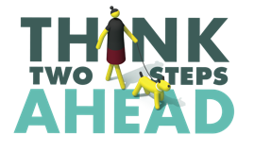
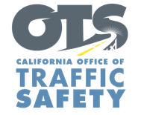
Add Agency Logo

FOR IMMEDIATE RELEASE Enter Month and Day, 2026
Enter Name, Phone Number and Email Address

October is National Pedestrian Safety Month
Drivers are urged to slow down and be alert for people walking

Enter Your City, Calif. – October is National Pedestrian Safety Month and the Enter Agency Name would like to remind drivers to take extra precautions to help protect people walking.

“In Enter City or Community, we’re committed to reinforcing everyday safety actions like slowing down, following the posted speed limit, staying alert and yielding to people in crosswalks,” Enter Agency Name, Title, First and Last Name said. “Drivers have an outsized role to keep all people walking safe. Remember that pedestrians do not have the same protections as drivers and passengers traveling inside vehicles.”

On average, 19 pedestrians are killed in traffic crashes every day in the United States, according to the National Highway Traffic Safety Administration. In 2024, an estimated 7,080 people walking were struck and killed by vehicles. Of those people, 1,090 were killed in California alone.

To promote the safety of people walking, Enter Agency name will
Enter specific dates and details of safety events, including open streets. Delete if not applicable. Enforcement ONLY: conduct a traffic safety operation on (Month and Day) from (Enter time period) focused on the most dangerous driver behaviors that put the safety of pedestrians at risk. These violations include speeding, making illegal turns, failing to yield and running stop signs or signals.

Enter Agency Name offers these driving tips to keep everyone safe:
- Follow the speed limit, especially in areas with heavy foot traffic, around schools and in neighborhoods where children are present.
- Slow down at intersections. Be prepared to stop for people crossing or walking at marked and unmarked crosswalks.
- Use extra caution when driving at night or when driving conditions are less than optimal such as rain or fog.
- Avoid distractions such as using a mobile device, deep conversations with passengers or eating while driving. Keep your focus on the road.
- Drive sober.

Delete if not Applicable Funding for this program is provided by a grant from the California Office of Traffic Safety, through the National Highway Traffic Safety Administration.

  

