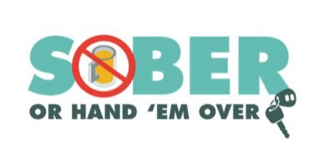

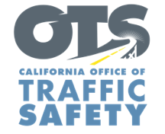
YOUR AGENCY LOGO

FOR IMMEDIATE RELEASE August XX, 2026
Enter Name, phone number and email address

Safe Drives Save Lives: Make the End of Summer Memorable
Enter your city, Calif. – Before the summer season winds down, Type Name of City Police or County Sheriff’s Department wants everyone to kick off their Labor Day festivities with safety at the forefront. Make the decision that saves lives. Choose safety every time you get behind the wheel and never drive under the influence of alcohol or drugs.

To help keep our community safe, the Enter Name of City Police or County Sheriff’s Department will have additional officers on patrol Aug. 19 through Labor Day (Sept. 1) looking for drivers suspected of driving under the influence of alcohol and/or drugs. The additional efforts to prevent impaired driving are part of a national enforcement campaign, Drive Sober or Get Pulled Over.

Delete if not applicable In addition to patrols, Type Name of City Police Department or County Sheriff’s Department will hold a DUI Checkpoint Type Month and Day or dates if holding multiple checkpoints from time in p.m. to time in a.m.at an undisclosed location within the city of Type name of city or county. Add specific location if allowed under department policy. Delete last two sentences if you do not disclose specific location of checkpoints.

“Enjoying the last days of summer should be all about fun and that starts with making safe choices before making plans,” Enter Rank, First and Last Name of City Police or County Sheriff’s Department said. “Everyone deserves to get home safely, and it starts with your everyday actions.”

According to the National Highway Traffic Safety Administration, 11,904 people were killed in drunk-driving crashes in the U.S. in 2024 — that’s one person every 44 minutes.

Enter Name of City Police or County Sheriff’s Department offers the following tips to Go Safely:

- Plan Ahead: If you know you’ll be drinking, arrange for a designated sober driver, call a ride-sharing service, taxi or use public transportation.
- Buckle Up: Wearing a seatbelt is one of the simplest ways to protect yourself in the event of a crash.
- Stay Alert: Avoid distractions such as texting or eating while driving. Keep your focus on the road.
- Follow Speed Limits: Speeding reduces your reaction time and increases the severity of crashes.
- Watch for Pedestrians and Bicyclists: With more people enjoying outdoor activities, be extra vigilant and look out for people biking and walking.
- Take Breaks: If you’re traveling long distances, take regular breaks to rest and avoid fatigue.

While drunk driving is a significant traffic safety problem, driving while impaired is not just from alcohol. Prescription drugs, over-the-counter medications and cannabis products may also impair. If you plan on drinking or taking medications with a driving warning label, let someone who is sober drive. If you see someone who appears to be driving while impaired, call 9-1-1.

Visit www.gosafelyca.org for more traffic safety information.

Funding for this program is provided by a grant from the California Office of Traffic Safety, through the National Highway Traffic Safety Administration. Delete this sentence if not applicable.

# # #

