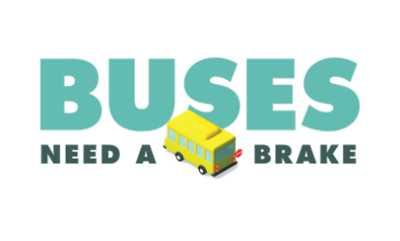
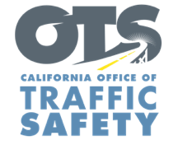
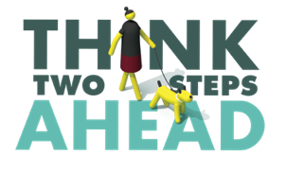
Enter Agency Logo

For Immediate Release August XX, 2026
Enter First Name, Last Name, Email and Phone Number

August is Back to School Safety Month: A+ Driving Starts with Slowing Down

Enter Your City, Calif. – As summer draws to a close and students prepare to return to school, the Enter Your Agency Name reminds all drivers to make safety a top priority during August’s Back to School Safety Month by slowing down, following the speed limit and being extra careful driving through school zones.

"This time of year brings increased activity around schools and it’s crucial to be mindful behind the wheel,” Enter Agency Name, Rank or Title, First Name, Last Name said. "Every driver plays a role in keeping children safe by slowing down and paying close attention in and around school zones. It is all our responsibility to ensure children get to and from school safely.”

The Enter Your Agency Name offers the following tips to stay safe around schools:
- Slow down and follow the speed limit.
- Adhere to school policies and procedures for dropping off and picking up students.
- Stop for school buses. Watch for children rushing to catch the bus or exiting.
- Look out for people walking and yield at all marked and unmarked crosswalks.
- For parents with children walking or biking to school, teach them safe walking and riding behaviors, such as looking both ways before crossing the street, using sidewalks when available and crossing at corners when there is no marked crosswalk.

If you are behind a school bus with a stop sign and flashing red lights, drivers need to stop so students can safely get on and off the bus. Drivers must remain stopped while the red lights are on. Drivers in both directions must stop on any two-lane road without a median or a center turn lane.

Visit www.gosafelyca.org for more traffic safety information.

###

