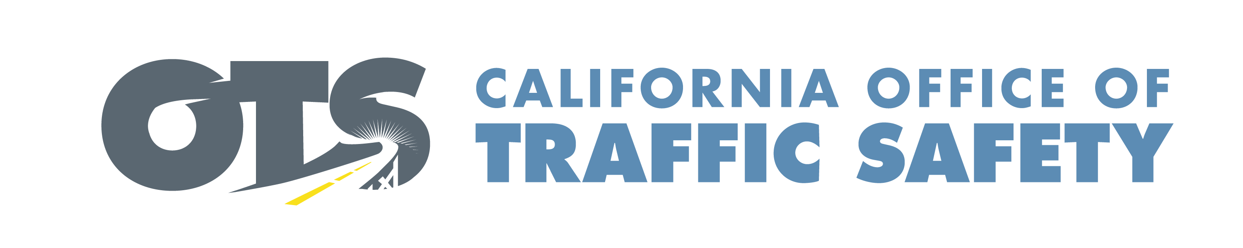

FOR IMMEDIATE RELEASE July Enter Date, 2026
Enter Contact First and Last Name
Enter Phone Number and Email

Speeding Catches Up With You:
Slow the Fast Down

Enter Your City, Calif. – This July and beyond, Enter Your Police/Sheriff’s Department Name encourages drivers to follow the speed limit and “slow the fast down.”

Delete if not applicable During the month of July (or specify dates), the Enter Your Police or Sheriff’s Department will have additional officers on patrol looking for drivers who are speeding or driving too fast for conditions.

Speeding remains a leading factor in deadly crashes and is consistently the top safety concern among surveyed California drivers, according to the 2025 California Traffic Safety Survey. Even small increases in speed reduce the time drivers have to react and significantly increases the force of a crash. Slowing down is a simple, effective way to prevent tragedies on our roads.

According to the National Highway Traffic Safety Administration (NHTSA), 11,288 people died from speeding-related crashes in the U.S. in 2024, accounting for 29% of all traffic fatalities that year. In California alone, 1,139 people were killed in speeding-related crashes in 2024.

“Speeding is dangerous and puts everyone at risk,” Enter Organization Name Title First and Last name said. “Your daily choice to drive within the speed limit protects everyone in our community. Risky driving behaviors like speeding continue to cause preventable tragedies on California roads.”

Drivers can take simple steps to prevent speeding:
- Plan ahead and allow extra travel time.
- Follow posted speed limits, especially in school and work zones.
- Drive at a speed that is safe for the conditions around you. Adjust your speed for changing weather, traffic and road conditions.
- Avoid aggressive driving behaviors like tailgating or weaving through traffic.

Crashes have severe and lasting consequences, and slowing down is one of the most important actions you can take to keep everyone using roads safe. By taking precautions and driving at safe speeds, we can make sure everyone in the community reaches their destination safely.



# # #

