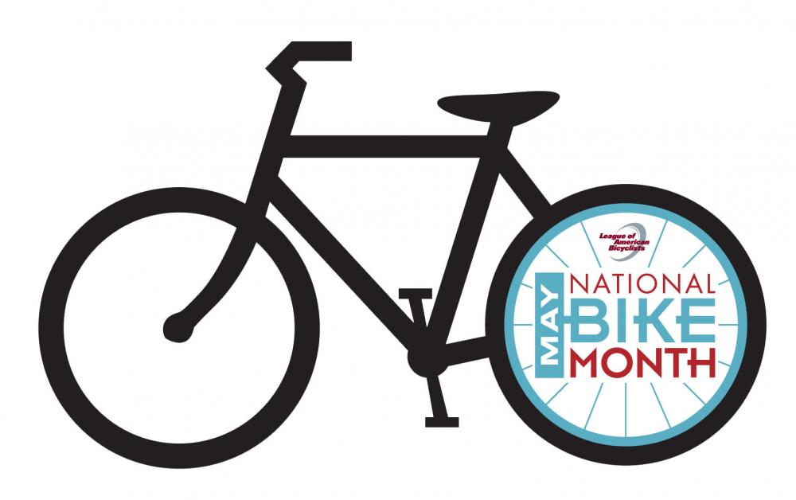
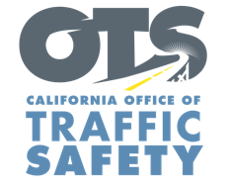

ENTER AGENCY LOGO
FOR IMMEDIATE RELEASE
Enter Month and Day, 2026
Enter First Name, Last Name, Phone Number and Email

May is National Bicycle Safety Month

Enter Your City, California – From children riding to school to older adults staying active and healthy, bicycling is both a pastime and a mode of transportation for thousands of Californians. May is National Bicycle Safety Month and the Enter Agency name is urging everyone to be alert to keep bicyclists safe.

According to the National Highway Traffic Safety Administration, there were 1,166 people killed while riding a bike on U.S. roads in 2023, and an estimated 49,489 bicyclists were injured. In California, there were 145 bicyclists killed in motor vehicle traffic crashes in 2023.

“It is important that we keep our bicyclists safe, as they do not have the same protections as drivers and passengers,” said Enter Title First Name Last Name. “People of all ages use bicycles to commute to school, work, and other activities. Bicyclists, like all road users, have the right to safe streets. We encourage drivers and bicyclists to look out for one another and practice safe habits so we may all go safely.”

*Law Enforcement Only.* Delete if not applicable To help keep people biking or walking safe, the Enter Agency name will conduct a traffic safety operation Enter date(s) and time(s) from a.m. to p.m. or p.m. to p.m. or if unknown, say “throughout the month” focused on driver behaviors that put bicyclists and pedestrians at risk, such as speeding, making illegal turns, failure to yield right of way and stop sign/red light running.

Enter Agency Name suggests the following safety tips for bicyclists and drivers:
Drivers
- Slow down and follow the speed limit. Be careful traveling through intersections.
- Look carefully for bicyclists and pedestrians before making a turn or opening a car door near streets or bike paths.
- Be patient when traveling behind a bicyclist and give them space when passing. California law requires drivers to change a lane, when possible, to pass bicyclists and always pass with at least 3 feet of space.
- Never drive distracted or impaired.

Bike Riders
- Use lights at night.
- Although not required for riders 18 and older, always wear a properly secured helmet. Helmets significantly reduce the chance of a head injury in the event of a crash.
- Bicyclists must travel in the same direction of traffic and have the same requirements as any slow-moving vehicle.
- Yield to pedestrians, just as a driver would. Pedestrians have the right-of-way within marked or unmarked crosswalks at intersections.

Funding for this program is provided by a grant from the California Office of Traffic Safety, through the National Highway Traffic Safety Administration.

# # #

