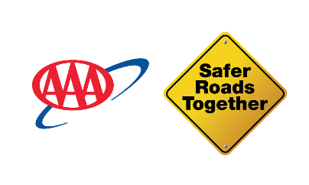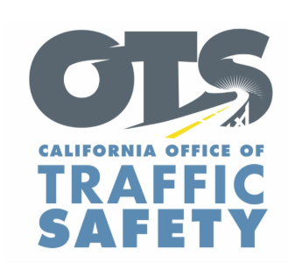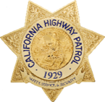
New Year, New Roadside Safety Protections: California’s Expanded “Slow Down, Move Over” Law Now Covers All Stopped Drivers and Passengers Roadside
With roadside deaths climbing at dangerous rates, AAA, OTS, CHP, Caltrans and survivor advocates urge drivers to obey the strengthened law now in effect.
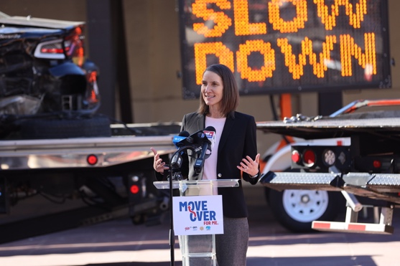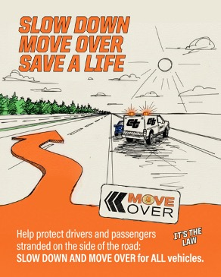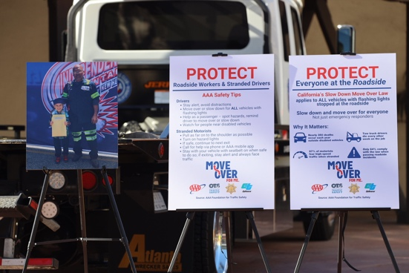
Los Angeles (January 27, 2026) — California’s expanded “Slow Down, Move Over” law officially took effect January 1, 2026, adding lifesaving protections for all stranded drivers and passengers on the roadside. The strengthened requirement compels drivers to move over, or slow down if unsafe to do so, for any stopped vehicle using hazard lights or emergency indicators, including everyday drivers experiencing mechanical trouble or emergencies.
The change, authorized under Assembly Bill 390, legislation sponsored by AAA, comes during a nationwide spike in roadside deaths that safety leaders are calling a crisis.
California Joins National Push to Protect Stranded Drivers
With AB 390 now in effect, California joins 28 other states, and the District of Columbia, with expanded Slow Down, Move Over protections to include all stopped vehicles.
Violations in California can result in:
• Fines up to $1,000, and
• Points on a driver’s record for unsafe behavior near stopped vehicles.
National Roadside Deaths Are Rising at Alarming Levels
The AAA Foundation for Traffic Safety, using data from the National Highway Traffic Safety Administration’s (NHTSA) Fatality Analysis Reporting System, reveals roadside fatalities are rising sharply. In California, the number of people killed roadside increased nearly 77% from 2014 to 2023. This alarming trend in people killed roadside is driven by higher speeds, distracted driving and limited shoulder space on modern freeways, data shows.
Additional recent national findings highlight the severity of the problem:
• According to the Emergency Responder Safety Institute, 46 emergency responders were killed last year in the U.S. after being struck while assisting at roadside scenes — police officers, firefighters, EMTs and tow truck operators.
• Tow operators face some of the deadliest conditions on America’s roadways.
• Hundreds of stranded drivers are killed every year while waiting for help or attempting simple fixes like changing a tire.
The Auto Club of Southern California says these numbers reflect a growing crisis, not isolated incidents.
“Slow Down. Move Over, and let’s protect every person stranded on our roadways. Together, we can turn a moment of caution into a statewide culture of care,” said Toks Omishakin, California Transportation Secretary. “Under the leadership of Governor Gavin Newsom, the California State Transportation Agency, Office of Traffic Safety, California Highway Patrol and Caltrans are coming together to make roadside stops moments of safety, not tragedy.”
“Whether you’re a stranded driver or a first responder, standing just feet from high-speed traffic has become increasingly deadly,” said Auto Club Corporate Communications Manager Doug Shupe. “This law equips California drivers with a clear, enforceable rule that can prevent more needless deaths.”
“Everyone traveling on California’s roads and highways deserves to arrive safely at their destination,” said Caltrans Director Dina El-Tawansy. “The provisions added to the Move Over law will help keep more people safe and continue protecting the highway workers and first responders risking their lives to serve others. When we make conscious decisions to benefit the safety of our fellow travelers and dedicated public servants, it creates a safer, more enjoyable travel experience for all.”
“Too many Californians are losing their lives simply because passing drivers fail to slow down or move over,” said CHP Commissioner Sean Duryee. “This expanded law makes clear that every person on the roadside, whether a driver or a passenger, deserves the same margin of safety. Obeying ‘Slow Down, Move Over’ is not just a courtesy; it is a legal responsibility that saves lives.”
“As you head out on your next trip, keep in mind that the driver with a flat tire or other roadside car trouble could very well be you,” OTS Director Stephanie Dougherty said. “Please move over a lane or slow down for highway workers, first responders, tow truck drivers and other stopped vehicles on the side of the road or shoulder. Make safety the destination we all share by looking out for every vehicle and person on the roadside.”
A Friend’s Loss That Shows What’s at Stake
Daniel Lazaro, a tow truck operator for Preferred Towing, lost his friend at the roadside in October last year. Fifty-seven-year-old Carlos Trejo was struck and killed while helping a stranded Auto Club member on 1-110.
“Carlos was a caring person who would always bring up his family in a joyful and proud way, especially his grandchildren,” said Lazaro. “As he would clock out every day to go home, he would always tell everyone clocking in to be careful and to be safe out there.”
Many Drivers Don’t Understand the Law and It’s Costing Lives
An Oct. 2025 national study from the AAA Foundation for Traffic Safety found:
• 36% of drivers captured on roadside video did not slow down or change lanes — violating the law entirely.
• Drivers were least likely to protect tow operators, with only 58% complying near stopped tow trucks.
• Two-thirds of drivers said they were familiar with “Slow Down, Move Over” laws, yet many could not accurately explain what was required.
The research also found that while some drivers do change lanes, many fail to reduce speed, leaving dangerously little margin if something goes wrong.
The Auto Club says stronger laws, paired with education, are essential to stop the rising death toll.
Effective Now: Simple Rules That Save Lives
As of January 1, drivers must take these simple actions when approaching a stopped vehicle:
1. Change lanes away from the stopped vehicle, if safe to do so.
2. If changing lanes is not possible, slow down to a safe, reasonable speed.
The message is clear:
See hazards or a stopped vehicle?
SLOW DOWN. MOVE OVER. SAVE A LIFE.

