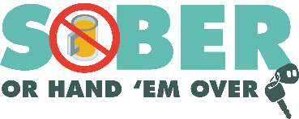
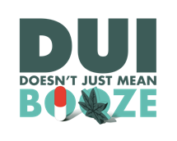
Agency logo/letterhead

FOR IMMEDIATE RELEASE

Enter Month, Day and Year
Enter Contact First Name and Last Name
Enter Phone Number and Email

Score Big on Safety: Celebrate Super Bowl Responsibly
Plan ahead with a sober ride before the big game

Enter Your City, California – As football fans gear up for the excitement of the big game, Enter Your Police or Sheriff’s Department reminds everyone that the best game plan includes getting home safely. Whether you're hosting a party, attending a gathering or enjoying the game at your favorite spot, planning ahead for a sober ride will keep you and everyone on the road safe.

“Super Bowl celebrations are a time for fun and community, but safety should always come first,” said Enter Rank or title First Name Last Name. “If you plan to drink, make sure you have a reliable way to get home, whether that’s a designated sober driver, rideshare, taxi or public transportation.”

On Super Bowl LX Sunday (February 8) If conducting DUI patrols on multiple days, say During Super Bowl LIX weekend (February 8 and 9), the Enter Your Police or Sheriff’s Department will have additional officers on patrol looking for drivers suspected of being under the influence of alcohol and/or drugs.

Plan for a Safe Celebration
Before heading out for Super Bowl festivities, follow these tips to stay safe:
- Designate a Sober Driver: Choose someone ahead of time who will stay alcohol-free and make sure everyone gets home safely.
- Use Ridesharing Services, Taxis or Public Transportation: Rideshare apps and transit options are safe alternatives to driving if you've been drinking.
- Host Responsibly: If you’re hosting, offer plenty of non-alcoholic beverage options and make sure your guests have safe, sober rides home.
- Look Out for Others: Don’t let friends or family members drive impaired. Take their keys and help arrange a safe ride.
- Never Drive Impaired or Distracted: It’s not worth the risk – your life and others’ lives depend on it!

Impaired driving is not just from alcohol. Prescription drugs, over-the-counter medications, cannabis products and other drugs may also cause impairment. If you plan on drinking or taking medications with a driving warning label, let someone who is sober drive. If you see someone who appears to be driving while impaired, call 9-1-1.

Delete if not applicable Funding for this program is provided by a grant from the California Office of Traffic Safety, through the National Highway Traffic Safety Administration.

# # #

