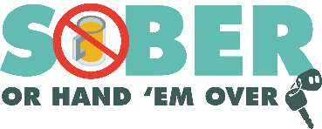
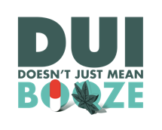
Agency logo/letterhead

FOR IMMEDIATE RELEASE

Enter Month, Day and Year
Enter Contact First Name and Last Name
Enter Phone Number and Email

The Enter Your Police or Sheriff’s Department
Encourages Safe St. Patrick’s Day Celebrations

Enter Your City, California – As St. Patrick’s Day approaches, Enter Your Police or Sheriff’s Department reminds everyone that the best way to celebrate the holiday is to plan ahead for a safe, sober way to get home. According to the National Highway Traffic Safety Administration, 1,355 people were killed in alcohol-impaired traffic crashes in California in 2023.

“We want people to make St. Patrick’s Day memorable for all the right reasons,” said Enter Rank or title First Name Last Name. “Before you raise a glass, make sure you’ve planned for a safe ride home, whether that’s a designated sober driver, rideshare, taxi or public transportation.”

Delete this if not applicable. Additional officers will be on patrol March 17 from enter time p.m. to time a.m. or p.m. looking for drivers suspected of driving under the influence of alcohol and/or drugs.

Delete this if not applicable. The Enter Your Police/Sheriff’s Department will conduct a driving under the influence (DUI) Checkpoint Enter Month and Day from Enter time p.m. to Enter time p.m./a.m. at an undisclosed location or add location depending on Department policy.

Plan for a Safe Celebration
Before heading out for St. Patrick’s Day festivities, follow these tips to stay safe:
- Designate a Sober Driver: Choose someone ahead of time who will stay alcohol-free and make sure everyone gets home safely.
- Use Ridesharing Services, Taxis or Public Transportation: Rideshare apps and transit options are safe alternatives to driving if you've been drinking.
- Host Responsibly: If you’re hosting, offer plenty of non-alcoholic beverage options and make sure your guests have safe, sober rides home.
- Look Out for Others: Don’t let friends or family members drive impaired. Take their keys and help arrange a safe ride.
- Never Drive Impaired or Distracted: It’s not worth the risk – your life and others’ lives depend on it!

Impaired driving is not just from alcohol. Prescription drugs, over-the-counter medications, cannabis products and other drugs may also cause impairment. If you plan on drinking or taking medications with a driving warning label, let someone who is sober drive. If you see someone who appears to be driving while impaired, call 9-1-1.

Delete if not applicable Funding for this program is provided by a grant from the California Office of Traffic Safety, through the National Highway Traffic Safety Administration.

# # #

