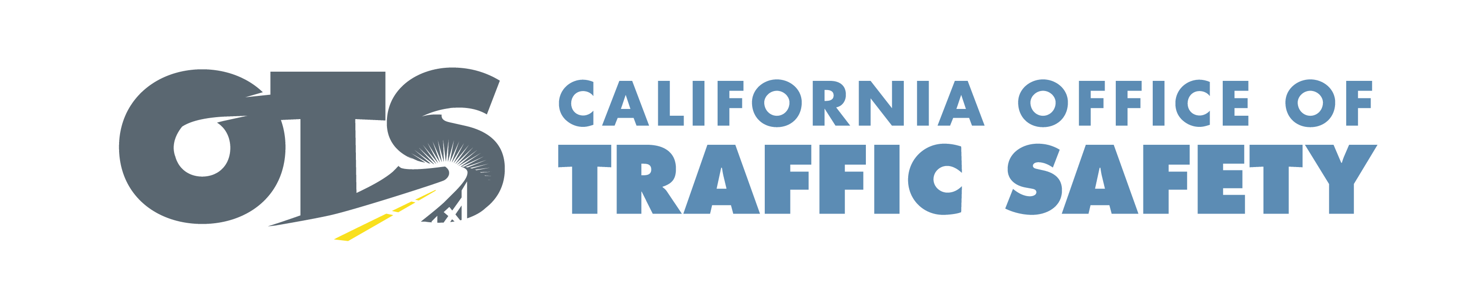

**FOR IMMEDIATE RELEASE**                                                  September Enter Date, 2025

Enter Contact First and Last Name

Enter Phone Number and Email

**Child Passenger Safety Week:**

**Protect Your Child with the Right Car Seat**

Enter Your City, Calif. – Enter Organization Name is joining law enforcement agencies, public health departments and other community organizations to raise awareness about the importance of keeping children in the correct car seat for their age and size.

During Child Passenger Safety Week, Enter Your Organization Name encourages all parents and caregivers to make sure their children are riding safely by using the correct car seats, booster seats and properly fitted seat belts. This annual campaign takes place from September 21-27.

“Every child deserves to travel safely,” Enter Organization Name Title First and Last name said. “During Child Passenger Safety Week, we urge all parents and caregivers to know for sure that their children are in the right seats and that those seats are installed correctly. Keeping a child in the right seat for their age and size can make all the difference in a crash.”

According to the National Highway Traffic Safety Administration (NHTSA), nearly half of car seats (46%) are misused. Properly installed car seats have been shown to reduce fatal injury crashes by 71% for infants under a year old and by 54% for toddlers ages 1 through 4.

[California law](https://www.chp.ca.gov/programs-services/programs/child-safety-seats) requires all children under 2 years old to ride in a rear-facing car seat, unless the child is 40 or more pounds or is 40 or more inches tall. Once a child reaches these milestones, all children under the age of 8 years old are still required to be secured in a car seat or booster seat, in the back seat. Children 8 and older, or who are at least 4 feet 9 inches tall, may be secured by a booster seat, but at a minimum must be secured by a safety belt.

Parents and caregivers are encouraged to keep children in the proper rear or forward-facing seat as long as possible and use the “[Five-Step Test](https://www.cdph.ca.gov/Programs/CCDPHP/DCDIC/SACB/CDPH%20Document%20Library/Child%20Passenger%20Safety%20Program%20(VOSP)/ChildSafetyBrochure_EngVer2023.pdf)” to determine if their child is big enough to safely use a seat belt without a booster seat.

To schedule a free child safety seat inspection, contact your [local CHP Area Office.](https://www.chp.ca.gov/find-an-office)

Visit [www.gosafelyca.org](http://www.gosafelyca.org) for more traffic safety information.

Delete if not applicable Funding for this program is provided by a grant from the California Office of Traffic Safety, through the National Highway Traffic Safety Administration.



  