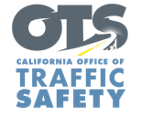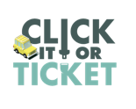

**FOR IMMEDIATE RELEASE**

Enter First Name, Last Name, Email, Phone Enter Month, Day, 2025

**“Click It or Ticket” Campaign Reminds   
Californians to Always Buckle Up**

*Seat Belt Safety Campaign Runs Through Memorial Day*

Enter Your City, California – Enter Agency Name reminds travelers to always buckle up and secure children in the right car seats when visiting friends and family.

This year’s *Click It or Ticket* campaign runs from May 12 to June 1. During this time, the Enter Agency Name will have additional officers on patrol actively looking for drivers and passengers who are not wearing a seat belt. This includes vehicles where children are not secured in child safety seats or the right safety seats for their age.

“Wearing a seat belt should be automatic for all drivers and passengers every trip,” Agency Name, Title or Rank, First and last name said. “Seat belts save lives, and everyone — front seat and back, child and adult — needs to remember always to buckle up.”

Nationally, [11,302 people killed in crashes in 2022](https://safetrec.berkeley.edu/2024-safetrec-traffic-safety-facts-occupant-protection-and-child-passenger-safety) were not wearing seat belts. In California, [842 people killed in crashes in 2022](https://safetrec.berkeley.edu/2024-safetrec-traffic-safety-facts-occupant-protection-and-child-passenger-safety) were not wearing seat belts, a decrease of 8.4 percent from 2021.

[California law](https://www.chp.ca.gov/programs-services/programs/child-safety-seats) requires all children under 2 years old to ride in a rear-facing car seat, unless the child is 40 or more pounds or is 40 or more inches tall. Once a child reaches these milestones, all children under the age of 8 years are still required to be secured in a car seat or booster seat. Children under the age of 8 may not ride in the front seat unless the vehicle is not equipped with a rear, forward-facing seat. Children 8 and older, or who are at least 4 feet 9 inches tall, may be secured by a booster seat, but at a minimum must be wearing a properly fitted safety belt.

Parents and caregivers are encouraged to keep children in the proper rear or forward-facing seat as long as possible and use the “[Five-Step Test](https://www.cdph.ca.gov/Programs/CCDPHP/DCDIC/SACB/CDPH%20Document%20Library/Child%20Passenger%20Safety%20Program%20(VOSP)/ChildSafetyBrochure_EngVer2023.pdf)” to determine if their child is big enough to safely use a seat belt without a booster seat.

Delete if not applicable The Enter Agency Name car seat safety program offers free inspections and help to install your car seat. For more information about the car seat safety program, visit Enter Contact Information

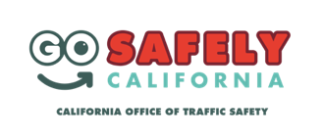Delete if not applicable Funding for this program was provided by a grant from the California Office of Traffic Safety, through the National Highway Traffic Safety Administration.

**###**