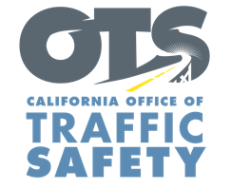
FOR IMMEDIATE RELEASE
May 1, 2024
National Heatstroke Prevention Day Serves as an Important Reminder to Stay Vigilant to Prevent Child Vehicular Heatstroke Deaths
On average, 37 children die per year due to vehicular heatstroke from being left in a car
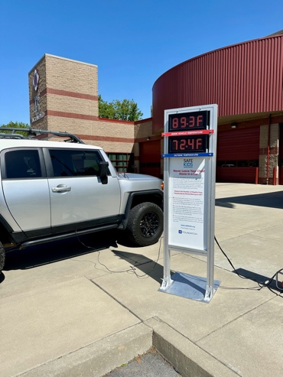
SACRAMENTO – On National Heatstroke Prevention Day, the California Office of Traffic Safety (OTS) and the Office of Community Partnerships and Strategic Communications stress the importance of taking proactive measures to prevent child vehicular heatstroke, one of the main causes of non-crash, vehicle-related deaths among children 14 and younger.
Since data on vehicular heatstroke among children was first tracked in 1998, more than 965 children have tragically lost their lives due to vehicular heatstroke. Each death was preventable, emphasizing the need for heightened awareness and action. While there has been a slight decrease in fatalities in recent years, the average of 37 deaths per year, according to data from the United States Department of Transportation (USDOT), remains concerningly high.
“It's crucial for all parents, caregivers and drivers to understand children should never be left alone in a vehicle, not even for a minute,” said OTS Director Barbara Rooney. “By making it a habit to check the back seat and always keeping car doors locked when no one is inside, we can prevent senseless tragedies and keep our most vulnerable passengers safe.”
The dangers are not limited to hot days or specific locations; fatalities can occur even when temperatures are as low as 57 degrees Fahrenheit. Heatstroke fatalities have happened in shaded areas and when outside temperatures were below 80 degrees Fahrenheit, according to USDOT data.
The scenarios in which vehicular heatstroke occurs are varied, including children being forgotten in vehicles, or children gaining access to unlocked vehicles, but change in routine poses the biggest risk factor, highlighting the importance of mindfulness and adopting preventive habits.
Children are one of the groups at greatest risk of heat illness, but as temperatures begin to rise across the state, it is important to make sure all Californians are prepared for extreme heat. California’s Heat Ready CA campaign encourages residents to be proactive in safeguarding themselves and their loved ones against the dangerous impacts of extreme heat.
“California’s hotter, drier future is here, and we expect that potentially dangerous heat waves will intensify, causing more risk for illness and death,” said Yumi Sera, Executive Director of the Governor’s Office of Community Partnerships and Strategic Communications. “Heat Ready CA offers simple, yet essential tips and resources to stay safer from extreme heat.”
The Heat Ready CA campaign collaborates across state agencies to provide Californians the information and resources they need to avoid the dangers of extreme heat.
It’s important to watch for the warning signs of heat illness, which can include heavy sweating, muscle cramps, weakness, headache, nausea or vomiting, paleness, tiredness, or dizziness.
The Office of Traffic Safety and the Office of Community Partnerships and Strategic Communications are sharing a few tips to help protect our loved ones:
- NEVER leave a child or pet unattended in a vehicle.
- Make it a habit to check the back seat EVERY time you exit the car.
- ALWAYS lock the car and keep keys out of reach. Teach children the vehicle is not a play area.
- During extreme heat events, make a personalized plan, stay cool, stay hydrated and look after each other.

By adhering to these simple yet vital practices, Californians can help prevent tragedies and safeguard the well-being of children and vulnerable community members. To learn more about car heat safety, visit https://www.safekids.org/heatstroke. For more information on staying safer during extreme heat go to HeatReadyCA.com.
###

ABOUT THE OFFICE OF COMMUNITY PARTNERSHIPS AND STRATEGIC COMMUNICATIONS
The Office of Community Partnerships and Strategic Communications (OCPSC) manages the State’s highest priority community engagement and public awareness efforts including COVID-19 vaccines, water conservation, extreme heat, and Individual Taxpayer Identification Numbers. The Office works with the respective agencies and departments to help inform campaign efforts and supports greater coordination and collaboration within state government.
The Office recognizes the vital role community partners play in helping to address the State’s most critical issues. In partnership with an ecosystem of trusted messengers, the Office directly engages Californians, including those experiencing the greatest health and social inequities, with culturally competent and actionable information, and meeting people where they are.
The Office builds upon successful community engagement and public awareness models developed through the California Census 2020 and COVID-19 vaccine campaigns. Learn more: www.opr.ca.gov/ocpsc.
ABOUT THE OFFICE OF TRAFFIC SAFETY
The OTS administers traffic safety grants that deliver innovative programs to eliminate traffic fatalities and injuries on California roads. Addressing behavioral issues such as alcohol and drug-impaired driving, distracted driving, occupant protection, and bicycle and pedestrian safety, the OTS strives to create safer roads for all. To learn more about the OTS, visit ots.ca.gov. Follow the OTS on Twitter and Instagram @OTS_CA, on Facebook at www.facebook.com/CaliforniaOTS and on the OTS YouTube channel.

