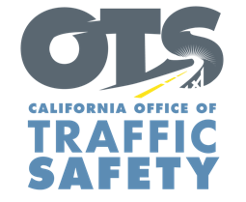
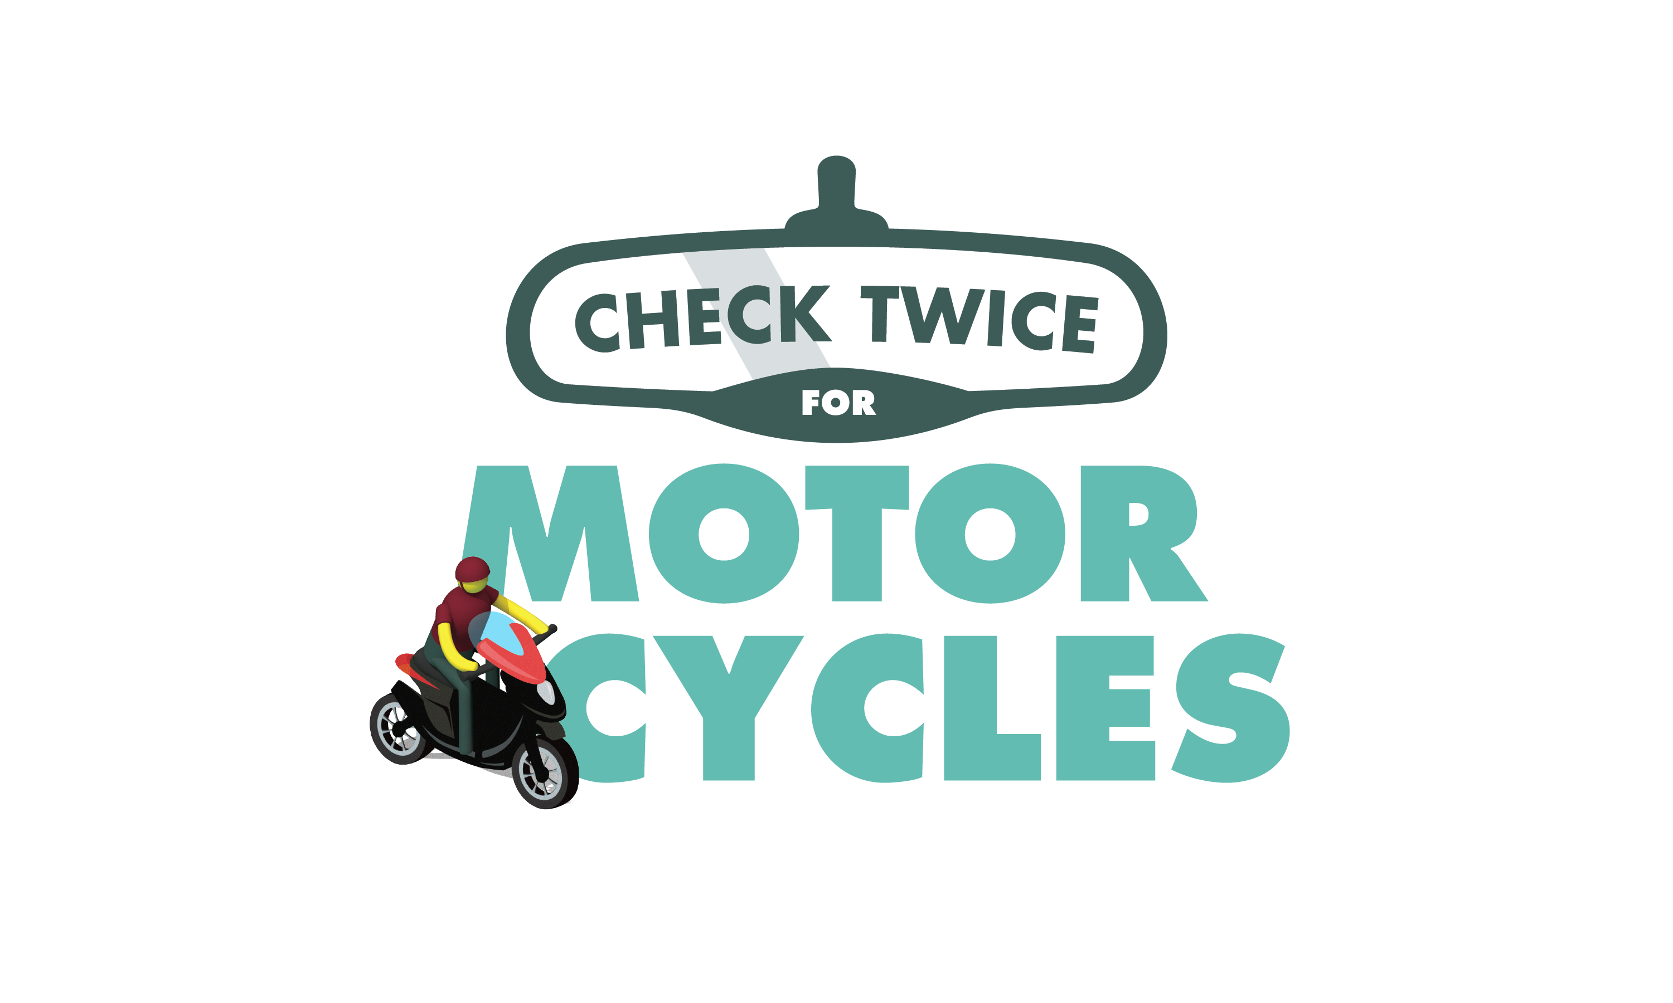

ENTER AGENCY LOGO

FOR IMMEDIATE RELEASE
Enter Month and Day, 2024
Enter First Name, Last Name, Email

Rev Up Safety: May is Motorcycle Safety Awareness Month

Enter Your City, Calif. — During Motorcycle Safety Awareness Month in May, Enter Agency name would like to remind drivers to always look twice for motorcycles. By practicing safe driving habits and taking shared responsibility on our roads, we can help everyone arrive at their destination safely.

“Motorcycles may be difficult to spot, so be extra careful before changing lanes,” Enter Title, First and Last name said. “A simple double take could mean the difference between a safe journey and a tragic crash. Motorcycle riders do not have the same protections drivers and passengers do. Let's all do our part to keep each other safe out there.”

According to National Highway Traffic Safety Administration data, there were 6,218 motorcyclists killed in traffic crashes in 2022. Motorcyclists were about 22 times more likely than passenger car occupants to die in a motor vehicle crash and four times more likely to be injured.

Delete if not applicable Throughout the month, Enter agency details about education or enforcement programs

To help protect you and your family, keep the following tips in mind while driving or riding:

Drivers
- Always check mirrors and blind spots before changing lanes.
- Do not follow a motorcycle too closely. Always keep a safe distance.
- If you see a motorcycle with a signal on, be careful. Be sure that the rider is turning before moving ahead.
Motorcyclists
- Always wear a U.S. DOT-compliant helmet with eye protection.
- Wear leather or other sturdy clothing such as a jacket, pants, boots with nonskid soles and gloves. Add reflective strips or decals to your clothing and motorcycle to make it easier for other drivers to see you.
- Ride defensively. Don’t assume a driver can see you. Avoid riding in a driver’s blind spot.
- Always keep your lights on, even during the day.
Lastly, both drivers and riders should never drive/ride distracted or under the influence of alcohol and/or drugs.

Delete if not applicable Funding for this program is provided by a grant from the California Office of Traffic Safety, through the National Highway Traffic Safety Administration.

  

