For Immediate Release
Date: April 17, 2024
Contacts:
Tim Weisberg, OTS Deputy Director, Marketing and Public Affairs
916-708-5128, timothy.weisberg@ots.ca.gov
Chris Clark, Caltrans Headquarters Deputy Division Chief, Public Affairs
916-531-3581, Christopher.clark@dot.ca.gov

Corona Family Affected by Distracted Driving Share Son’s Tragic Story in New PSAs Released Today
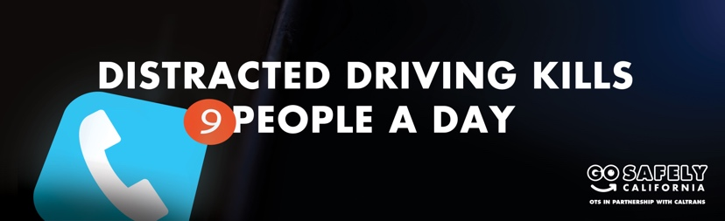
WHAT YOU NEED TO KNOW: The California Office of Traffic Safety (OTS) and California Department of Transportation (Caltrans) today released new public service announcements (PSAs) featuring the parents of 21-year-old Corona native Benjamin “Bean Dip” Montalvo. In June 2020, Benjamin was tragically struck and killed while riding his bike by a distracted and impaired driver.

SACRAMENTO – A Corona family that has personally experienced the tragic consequences of distracted driving is sharing their story as part of a new public awareness campaign. Through the end of April – National Distracted Driving Awareness Month – new English and Spanish PSAs will run on multiple media platforms to raise awareness about the dangers of texting and cell phone use while driving, as well as to underscore the courageous commitment of Kellie and Eddie Montalvo.
In the PSAs, the Montalvos share their personal tragedy and warn others against making the dangerous decision to drive distracted.
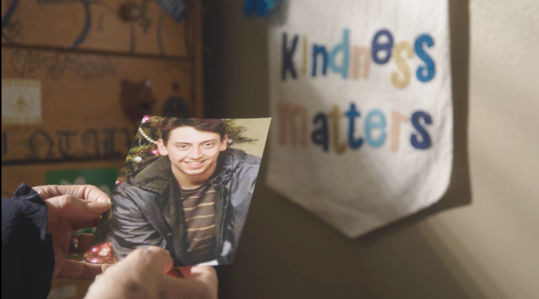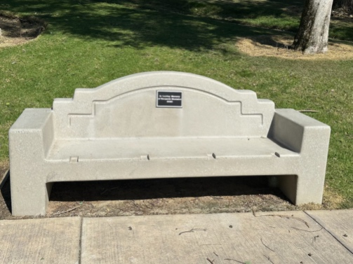
BENJAMIN’S MOTHER, KELLIE MONTALVO: “This destroyed us in so many ways. No parent should bury a child. No brother should carry a casket and no friend should have to see their friend die all because of a phone in someone’s hand.”
OTS DIRECTOR, BARBARA ROONEY: "The Montalvos are grieving parents and their entire family experienced unimaginable loss because someone made the destructive decision to drive distracted and impaired. Their advocacy and commitment to safer roads is courageous in the face of personal tragedy. Benjamin's story is a call for all of us to act so no more children, parents, neighbors, and friends are killed in preventable crashes. Please, never drive distracted – someone’s life could be at stake."
CALTRANS DIRECTOR, TONY TAVARES: “The tragic death of 21-year-old Benjamin serves as a stark reminder of the devastating consequences of distracted driving. Distracted driving is not just a momentary lapse, it is a conscious choice that causes irreversible harm with catastrophic consequences. Let us make a commitment to drive with vigilance, responsibility, and above all, compassion for those other lives sharing the road with us.”
WHY THIS MATTERS: April is National Distracted Driving Awareness Month. Nine people are killed every day in the U.S. in distracted driving related crashes. In 2022, 3,308 people were killed in distracted driving related crashes throughout the country. The numbers are likely underreported because law enforcement officers may not always be able to determine that distraction was a factor in a crash. Every person killed in crashes involving a distracted driver was potentially preventable. According to the 2023 California Statewide Public Opinion Survey, more than 74% of drivers surveyed said that distracted driving due to texting was their biggest safety concern.
VIDEO FOR NEWS MEDIA (click links to view and download):
English and Spanish PSAs
Benjamin Montalvo B-roll
Kellie Montalvo (Benjamin’s Mother) Soundbites (English)
Eddie Montalvo (Benjamin’s Father) Soundbites (Spanish)
OTS Director Soundbite (Audio Only)
PSA & Campaign Information: The PSAs are part of the ‘Distracted Driving Kills’ paid media campaign which runs through April 30 and features a series of English and Spanish safety messages on video, digital billboards, digital platforms including social media and streaming services, and audio messages on the radio.
Visit www.gosafelyca.org for more traffic safety information. Read Full Release.

###

