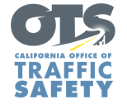
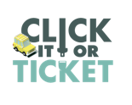

FOR IMMEDIATE RELEASE
Enter First Name, Last Name, Email, Phone Enter Month, Day, 2024

“Click It or Ticket” Campaign Reminds
Californians to Always Buckle Up
Seat Belt Safety Campaign Runs Through Memorial Day

Enter Your City, Calif. – For Memorial Day Weekend, Enter Agency Name reminds travelers to always buckle up and secure children in the right car seats when visiting friends and family.

This year’s Click It or Ticket campaign runs from May 20 to June 2. During this time, the Enter Agency Name will have additional officers on patrol actively looking for drivers and passengers who are not wearing a seat belt. This includes vehicles where children are not secured in child safety seats or the right safety seats for their age.

“Wearing a seat belt should be automatic for all drivers and passengers every trip,” Agency Name, Title or Rank, First and last name said. “Seat belts save lives, and everyone — front seat and back, child and adult — needs to remember always to buckle up.”

According to the National Highway Traffic Safety Administration (NHTSA), nearly 12,000 people killed in crashes throughout the country in 2021 were not wearing seat belts. In California, 878 people killed in crashes in 2021 were not wearing seat belts, an increase of 12.3 percent from 2020.

California law requires a child to be secured in a safety or booster seat until they are at least 8 years old or at least 4 feet, 9 inches tall. Children under the age of 2 must ride in a rear-facing seat unless the child weighs 40 or more pounds or is 40 or more inches tall.

Delete if not applicable The Enter Agency Name car seat safety program offers free inspections and help to install your car seat. For more information about the car seat safety program, visit Enter Contact Information

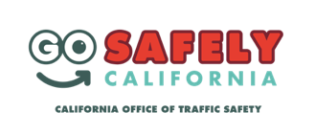
Delete if not applicable Funding for this program was provided by a grant from the California Office of Traffic Safety, through the National Highway Traffic Safety Administration.

###

