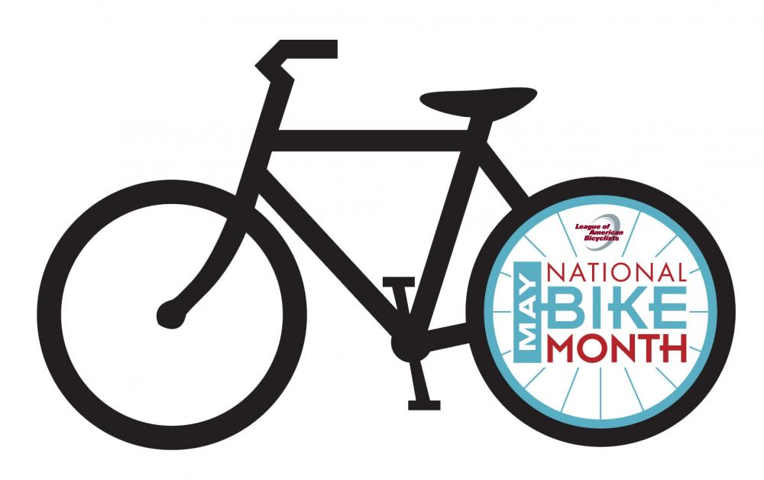
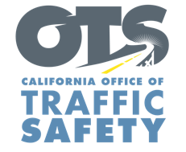
ENTER AGENCY LOGO
FOR IMMEDIATE RELEASE
Enter Month and Day, 2024
Enter First Name, Last Name, Phone Number and Email

Share the Road and Look Out for One Another During Bicycle Safety Month

Enter City, Calif. — May is National Bicycle Safety Month, and Enter Agency name is encouraging everyone to get active and safely take bike rides while at the same time reminding drivers to be on the lookout for more people biking and walking.

“Everyone deserves to reach their destination safely,” Enter Title, First Name last name said. “Unfortunately, there has been an increase in bicycle fatalities and injuries over the last few years. Bicyclists do not have the same protections as people in a vehicle so if you see a bicyclist — slow down.”

According to the National Highway Traffic Safety Administration, there were 1,105 people killed while riding a bike in 2022, and an estimated 46,195 bicyclists were injured. In 2021, 976 bicyclists were killed (a 1.9% increase from 2020) and an estimated 41,615 bicyclists were injured (a 7% increase from 2020).

*Law Enforcement Only.* Delete if not applicable To help keep people safe while biking or walking , the Enter Agency name will conduct a traffic safety operation Enter date(s) and time(s) from a.m. to p.m. or p.m. to p.m. or if unknown, say “throughout the month” focused on driver behaviors that put bicyclists and pedestrians at risk, such as speeding, making illegal turns, failure to yield right of way, and stop sign/red light running.

Enter Agency Name suggests the following safety tips for bicyclists and drivers:
Drivers
- Slow down and follow the speed limit. Be careful traveling through intersections.
- Look carefully for bicyclists and pedestrians before making a turn or opening a car door near streets or bike paths.
- Be patient when traveling behind a bicyclist and give them space when passing. California law requires drivers to change a lane, when possible, to pass bicyclists and always pass with at least 3 feet of space.
- Never drive distracted or impaired.

Bike Riders
- Use lights at night.
- Although not required for riders 18 and older, always wear a properly secured helmet. Helmets significantly reduce the chance of a head injury in the event of a crash.
- Bicyclists must travel in the same direction of traffic and have the same requirements as any slow-moving vehicle.
- Yield to pedestrians, just as a driver would. Pedestrians have the right-of-way within marked or unmarked crosswalks at intersections.

Funding for this program is provided by a grant from the California Office of Traffic Safety, through the National Highway Traffic Safety Administration.

# # #

