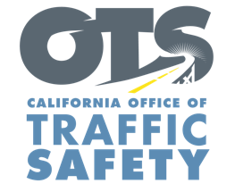
Enter Your Agency Logo

FOR IMMEDIATE RELEASE: April Enter Day, 2024
Enter First Name, Last Name
Email and Phone Number

DUI Doesn’t Just Mean Booze: Best Buds Stay Sober Behind the Wheel

Enter City, Calif. – With 4/20 celebrations approaching, the Enter Agency Name reminds everyone to celebrate responsibly and prioritize their own safety and that of others. Although recreational and medicinal use of marijuana is legal in California, don’t let the high times cloud judgment on the road.

“Whether it is on 4/20 or any other day, it is unsafe and illegal to drive under the influence of marijuana,” Enter Rank or title, first and last name said. “It’s important to make responsible choices, especially when it comes to getting behind the wheel.”

If you plan to participate in 4/20 activities and consume marijuana, plan ahead, designate a sober driver or consider staying in and ordering delivery from local establishments. Do not drive, and never ride with an impaired driver. Driving under the influence of marijuana is dangerous, illegal and has serious consequences.

Studies have shown that THC, the active ingredient in marijuana, can slow reaction times and make it more difficult for drivers to judge distances and keep a steady position in their lane.

If you see an impaired driver on the road, safely pull over and call 911.

Delete if not applicable Funding for this program is provided by a grant from the California Office of Traffic Safety, through the National Highway Traffic Safety Administration.



