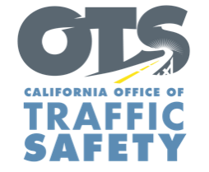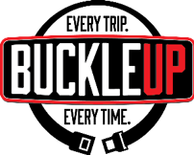

Add Agency Logo

FOR IMMEDIATE RELEASE

Date
Contact First Name Last Name
Contact Email
Contact Phone Number

Enter Your Police Department Conducting Seat Belt
Enforcement Operation Enter Month and Day

Enter City, Calif. – On Enter Month and Day, the Enter Your Police Department will be out looking for drivers and passengers who are not wearing their seat belt. This also includes drivers who do not secure children in child safety seats.

“Buckling up is your best defense in the event of a crash, and only takes a few seconds,” Enter Rank or Title First Name Last Name said. “The same goes for car seats. Children should be as safe as possible when riding in the car, and one major way to do that is to make sure they are secured in the correct car seat.”

Under California law, children under two years old who weigh under 40 pounds or are under 40 inches tall must ride in a rear-facing car seat. Children under the age of eight or under 4’ 9” tall must be secured in a car or booster seat.

To find a car seat fitting station near you, visit the California Office of Traffic Safety website, or California Highway Patrol’s office finder.

Delete if not applicable Funding for this program is provided by a grant from the California Office of Traffic Safety, through the National Highway Traffic Safety Administration.


  

