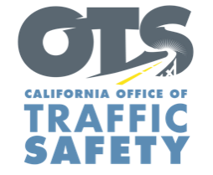

Add Agency Logo

FOR IMMEDIATE RELEASE

Date
Contact First Name Last Name
Contact Email
Contact Phone Number

Enter Number Drivers, Motorcyclists Cited During
Motorcycle Safety Enforcement Operation

Enter City, Calif. – Enter Agency name cited Enter number drivers and motorcycle riders for a variety of violations.

During the operation Enter Month and Day from Enter time p.m. to p.m. or a.m. to p.m., Enter specific number for each citation (speeding, failure to yield, improper turn, DUI, etc.)

Enter Agency name will hold another motorcycle safety enforcement operation Enter Month and Day, delete sentence if not applicable.

Delete if not applicable Funding for this program was provided by a grant from the California Office of Traffic Safety, through the National Highway Traffic Safety Administration.

# # #

