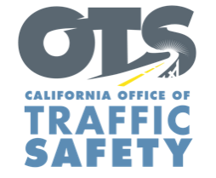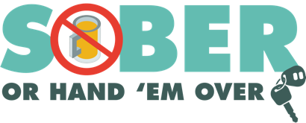

Add Agency Logo

FOR IMMEDIATE RELEASE

Date
Contact First Name Last Name
Contact Email
Contact Phone Number

Name of Department Visit Businesses to Educate
the Public on How to “Know Your Limit”

Enter City, Calif. – On month and date, the Enter Agency Name
will visit local bars and restaurants to educate customers on the importance of monitoring how much they drink and to “know your limit.” The “Know Your Limit” campaign will be from time in p.m. to time in a.m. in the enter specific bars, restaurants or business district. If not specified, say “throughout the city or county of…

The “Know Your Limit” program raises awareness about the dangers of drinking and driving and is an interactive way to show how much, or little, it can take to reach the legal limit to operate a vehicle. Officers will ask customers how many drinks they have consumed and whether they believe they are still able to drive safely. Officers will then invite volunteers to take a breathalyzer test to see if they are able to guess their blood alcohol content (BAC). Customers are provided information on alcohol intake and average BAC levels.

It is illegal for anyone 21 or older to drive with a BAC of .08% or higher.

According to the California Driver Handbook, it takes two drinks consumed within one hour by a woman between 120-160 pounds and three drinks by a man between 180-220 pounds to be over the legal limit of .08%. One drink is based on 1.5 oz. of liquor (40% alcohol), 12 oz. of beer (4.5% alcohol) or a 5 oz. glass of wine (12% alcohol). The BAC lowers at a rate of .01% for every 40 minutes between drinks.

“The goal is to help people understand the effects of alcohol so they can make smart decisions about how they get home,” Enter Rank or title First Name Last Name said. “It only takes a few drinks to impair, and that’s why it is important that people know their limit.”

The average cost of a first-time DUI offense is approximately $13,500, accounting for vehicle impound fees, fines, attorney fees, auto insurance hikes and other penalties. Plan ahead and avoid the risk of a DUI by designating a sober driver.

Funding for the “Know Your Limit” program is provided by a grant from the California Office of Traffic Safety, through the National Highway Traffic Safety Administration.

# # #

