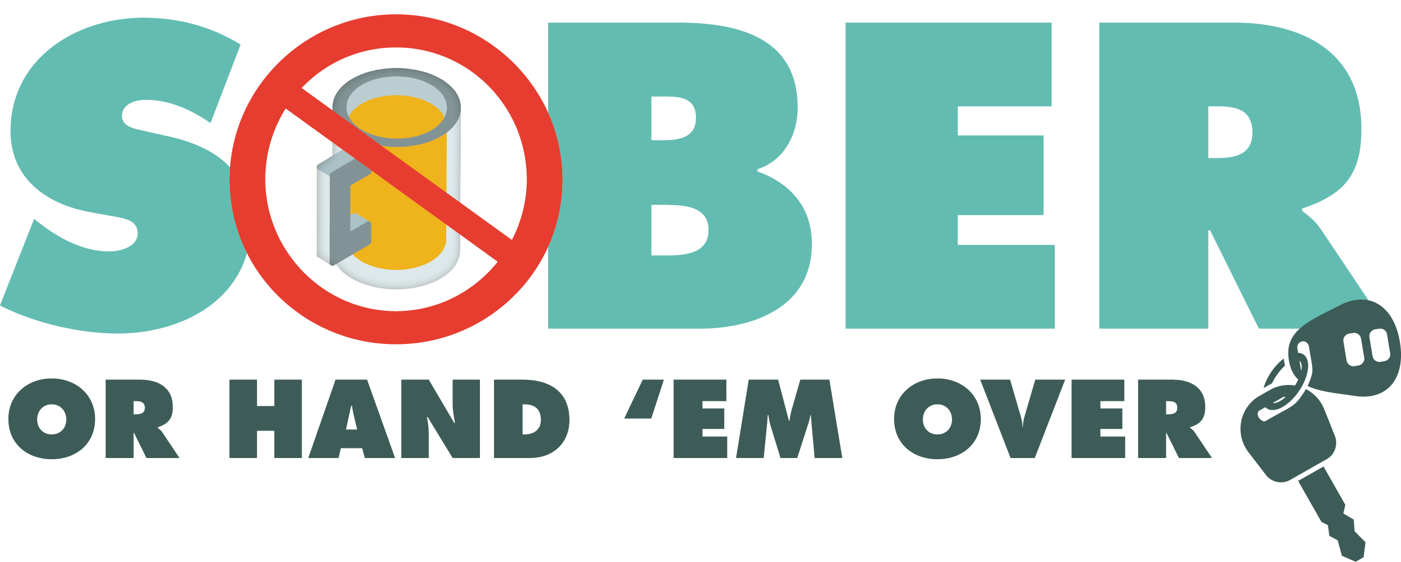

Add Agency Logo

FOR IMMEDIATE RELEASE

Date
Contact First Name Last Name
Contact Email
Contact Phone Number

Enter Number Arrested or Cited at Enter City or County DUI Checkpoint

Enter City, Calif. – On Enter Date Enter number arrested for DUI. If no arrests, highlight any citations issued, such as driving with suspended/revoked license or without a license. at a DUI checkpoint on Enter Date.

The DUI checkpoint was held at Enter street location and nearest intersection from Enter time p.m. to time a.m.

Delete if not applicable Enter number drivers were cited for operating a vehicle unlicensed or with a suspended/revoked license, Enter number vehicles were contacted. Enter Number arrested for other criminal charges. Enter specific charges.

DUI checkpoint locations are determined based on reported incidents of impaired driving-related crashes. The primary purpose of DUI checkpoints is to promote public safety by taking suspected impaired drivers off roads.

The next DUI checkpoint will be held on Enter Date. Delete if not applicable.

Funding for this checkpoint was provided by a grant from the California Office of Traffic Safety, through the National Highway Traffic Safety Administration.

# # #

