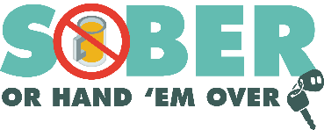
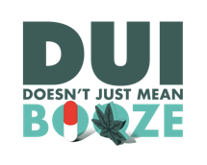
Agency logo/letterhead

FOR IMMEDIATE RELEASE

Enter Month, Day and Year
Enter Contact First Name and Last Name
Enter Phone Number and Email

Kick Off Super Bowl LVIII with a Go Safely Game Plan

Your City, Calif. – As the excitement builds for Super Bowl LVIII, the Enter Your Police or Sheriff’s Department reminds football fans to intercept impaired driving if they’re heading out to a Super Bowl party and plan on drinking. Make sure you stick to the “Go Safely” game plan and choose a sober way to go.

On Super Bowl LVIII Sunday (Feb. 11) If conducting DUI patrols on multiple days, say During Super Bowl LVIII weekend (Feb. 10 & 11), the Enter Your Police or Sheriff’s Department will have additional officers on patrol looking for drivers suspected of being under the influence of alcohol and/or drugs.

“Let's make sure Super Bowl Sunday is remembered for great plays on the field, not for unnecessary risks on the road,” Enter Rank or title First Name Last Name said. “Before you grab a drink, plan ahead for a sober designated driver. Choosing a safer way to go is a win-win for everyone.”

Enter Police of Sheriff’s Department reminds the public that alcohol is not the only substance that impairs. Marijuana, prescription medications, and over-the-counter drugs may also impair your ability to drive safely. Do your research and understand how certain drugs may affect you.

Delete if not applicable Funding for this program is provided by a grant from the California Office of Traffic Safety, through the National Highway Traffic Safety Administration.

###

