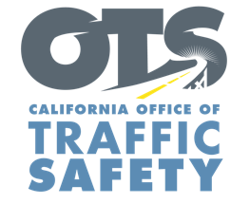
Enter Your Agency Logo

FOR IMMEDIATE RELEASE: December Enter Day, 2023
Enter First Name, Last Name, Email and Phone Number

Make This a Holiday Season to Remember:
Celebrate Responsibly with a “Go Safely” Game Plan
National “Drive Sober or Get Pulled Over” Enforcement Campaign Begins Dec. 13

Enter City, Calif. – The holiday season can be a dangerous time for people on the roads. In December 2021 alone, 1,013 people were killed in the U.S. in alcohol-impaired-driving crashes according to the National Highway Traffic Safety Administration. Enter Agency Name wants to remind the public of the dangers of driving impaired and celebrate the holiday season responsibly by not driving under the influence.
Delete if not applicable From Dec. 13 through New Year’s Day, Enter Agency Name will have additional officers on patrol looking for drivers suspected of being under the influence of alcohol and/or drugs. The high-visibility enforcement effort is part of a national campaign, Drive Sober or Get Pulled Over, with the goal of stopping suspected impaired drivers who put others on the road at risk.

“Impaired driving isn’t just dangerous, it’s illegal,” Enter Rank or title First and Last Name said. “Let’s make this a joyful and safe holiday season for everyone on the road. This enforcement period allows us to get the message out that it is essential to act responsibly and plan a sober ride home.”

Enter Agency Name encourages everyone to stay in for the night or have a “go safely” game plan by scheduling a ride or designating a sober driver if you plan to consume alcohol.

Impaired driving is not just from alcohol. Marijuana, prescription medications or over-the-counter drugs may also impair. Do your research and understand how certain drugs may affect your driving ability.

Delete if not applicable Funding for this program is provided by a grant from the California Office of Traffic Safety through the National Highway Traffic Safety Administration.



