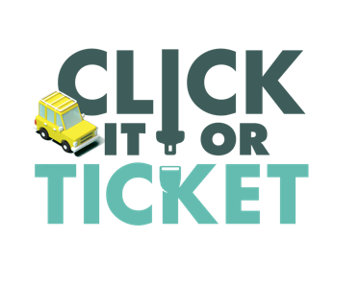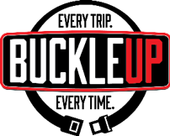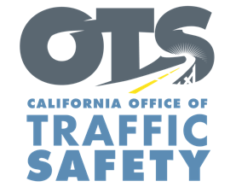

ADD AGENCY LOGO

**FOR IMMEDIATE RELEASE: November Enter Day, 2023**

**CONTACT:** EnterName, Phone Number, E-mail address

**Enter City or County Agency Encourages Everyone to Travel Safely During the Thanksgiving Holiday**

Enter Your City, Calif. – As millions of families throughout the state hit the road to visit friends and family this Thanksgiving holiday, Enter City or County Agencyreminds drivers and passengers the importance of wearing a seat belt, and the potentially deadly consequences of not buckling up.

Thanksgiving is one of the busiest travel times of the year. According to AAA, 55.4 million people are expected to travel 50 miles or more from home this Thanksgiving holiday, up 2.3% from 2022. With more cars on the road, the chances of being involved in a crash go up, and a seat belt is the best defense.

"Whether you're traveling near or far for Thanksgiving, our top priority is for everyone to have a safe and enjoyable holiday," said [Title/ Rank] [First Name] [Last Name]. "Wearing a seatbelt is the most effective way to protect yourself in the event of a crash. Therefore, it is essential for drivers and passengers alike to fasten their seatbelts every time they travel."

Delete if not applicable During the Thanksgiving holiday Nov. 22-26 Enter Your Agency will conduct operations Enter any specific dates and times of operations specifically focused on drivers and passengers who are not wearing their seat belt, including children who are not secured in child safety seats.

Under California law, children under two years old who weigh under 40 pounds or are under 40 inches tall must ride in a rear-facing car seat. Children under the age of eight or under 4’ 9” tall must be secured in a car or booster seat.

Delete if not Applicable Funding for this program is provided by a grant from the California Office of Traffic Safety, through the National Highway Traffic Safety Administration.

**###**