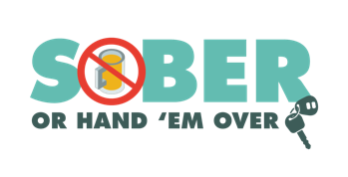
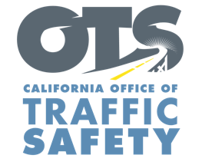
Enter Your Agency Logo
FOR IMMEDIATE RELEASE: November XX, 2023
Enter First Name, Last Name, Email and Phone Number

‘Tis the Season to Make a Plan: Be Safe and Drive Sober

Enter City, Calif. – Millions of people will be traveling to visit friends and family over the holidays. The Enter Agency Name encourages everyone to celebrate safely and have a holiday game plan that includes a designated sober driver.

Delete if not applicable During the pre-Christmas and New Year’s holiday season Nov. 27-Dec. 12, Enter Agency Name will have additional officers on patrol looking for drivers suspected of driving under the influence of alcohol and/or drugs.

"We want everyone to enjoy the holidays and stay safe," said [Enter Title or Rank, First and Last Name]. "If you intend to go out and celebrate, please plan ahead and arrange for a safe, sober ride home. Driving under the influence should never be an option."

Drunk driving is a problem on our nation’s roads every day, but it’s more prevalent during the holidays. During the 2017-2021 December months, there were more than 4,500 people killed in drunk-driving-related crashes.

Enter Agency Name reminds drivers that a “DUI Doesn’t Just Mean Booze.” Prescription medications, over-the-counter drugs and marijuana can also impair, especially in combination with alcohol and other drugs. Do your research and be informed about how certain drugs may affect your driving ability.

Delete if not applicable Funding for this program is provided by a grant from the California Office of Traffic Safety, through the National Highway Traffic Safety Administration.


  

