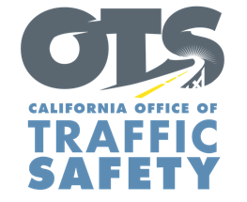
Add Agency Logo

FOR IMMEDIATE RELEASE Enter Month and Day, 2023
Enter First Name, Last Name, Email, Phone Number

Enter Your Agency Name Awarded Grant from the Office of Traffic Safety to Improve Traffic Data Reporting

Enter Your City, Calif. – Enter Your Agency Name received a $Enter Money Amount grant from the California Office of Traffic Safety (OTS) for a traffic records improvement project to report crash and citation data faster and more efficiently.

“By adopting a data-driven approach to traffic management, we have the opportunity to increase safety on the roads within our community,” Agency name title first and last name said. "With this funding, we will be able to deploy a state-of-the-art electronic system for reporting crash and citation data, a significant stride towards improving our responsiveness by focusing on high-priority traffic resource areas.”

Grant funds will pay for a new electronic crash and citation data reporting system.
Delete any activities that are not part of your grant objectives, Add additional grant objectives not listed

Funding for this program was provided by a grant from the California Office of Traffic Safety, through the National Highway Traffic Safety Administration.

# # #

