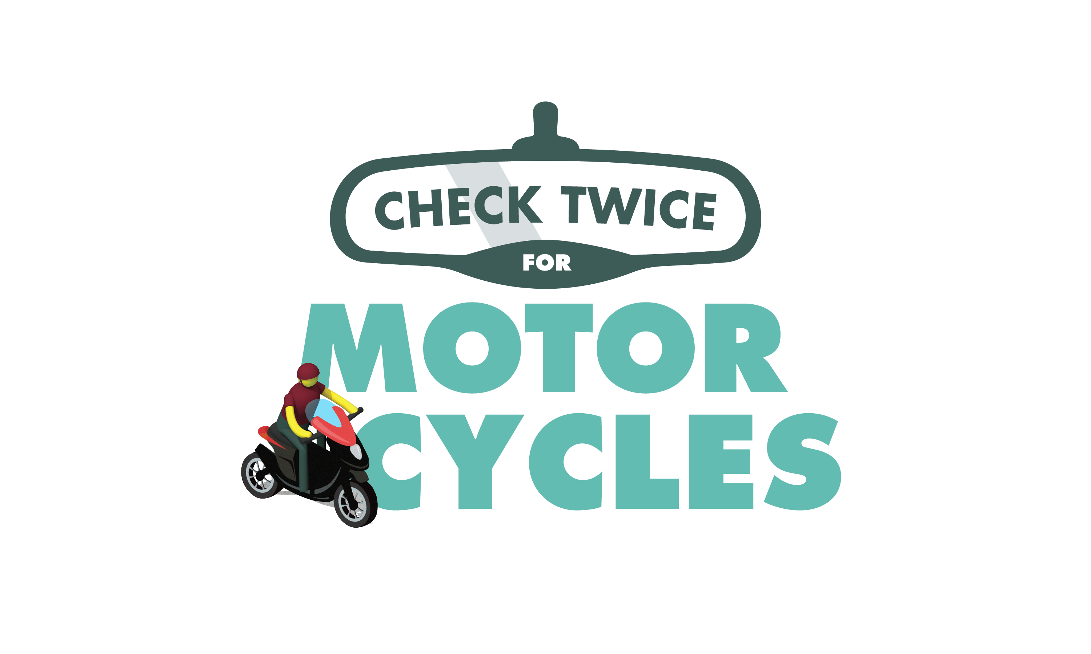
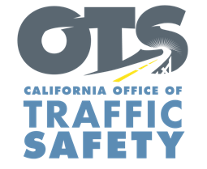

Add Agency Logo

FOR IMMEDIATE RELEASE
Enter Month and Day, 2023
Enter First Name, Last Name, Email

Ride to Live: Enter Agency Name Receives Grant from the Office of Traffic Safety for Motorcycle Safety Training Program

Enter Your City, Calif. — The Enter Agency Name received grant funding from the California Office of Traffic Safety (OTS) to promote motorcycle safety awareness with free, hands-on rider trainings led by local law enforcement.

The Enter $ Amount grant will pay for a series of free motorcycle safety classes that allow riders to practice braking, turning, steering, entering traffic and other skills that help avoid crashes and improve rider safety on the road.

“The Ride to Live program will allow us to make a real difference in our community by providing high-quality motorcycle safety education and training to riders,” Enter Agency rank First Name Last Name said. “We believe education is the key to preventing crashes and creating safer roads for drivers, passengers, bicyclists, and pedestrians.” Suggested quote. Feel free to use own words about goal of the program and importance of working on riding skills.

The motorcycle training program will run through September 2024.

Classes will be available starting Enter Month and/or Date. To register for a free training class, visit Add Link to Registration

Funding for this program is provided by a grant from the California Office of Traffic Safety, through the National Highway Traffic Safety Administration.

  

