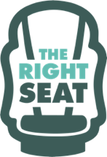
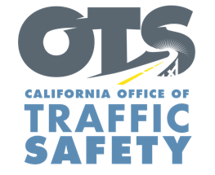
Add Agency Logo

FOR IMMEDIATE RELEASE
Enter Month and Day, 2023
Enter First Name, Last Name, Email, Phone Number

Enter Agency Name Awarded Grant from the Office of Traffic Safety for Child Safety Seat Education Program

Enter Your City, Calif. – Enter Your Agency Name received a $Enter Funding Amount grant from the California Office of Traffic Safety (OTS) to support our efforts in educating parents and caregivers about the importance of child safety seats and making sure that every child in our community travels safely.

“This grant reinforces our dedication to raising awareness about the proper use and installation of child safety seats,” Enter Organization Name Title First and Last Name said. “With this support, we can reach even more families, offer valuable education, and provide child safety seats to those in need.”

Funds will be used for a variety of community outreach events, education classes, distribution of child safety seats, and training on the installation and use of child safety seats.

The car seat safety program includes:
- Child safety seat inspection events and education classes.
- Child Passenger Safety Technician (CPST) training and recertification courses.
- Child safety seats at no-cost for families in need.
- Partnering with local organizations on car seat safety community outreach efforts in underserved communities.
Delete or add activities in grant agreement

The program runs through September 2024.

Funding for this program was provided by a grant from the California Office of Traffic Safety, through the National Highway Traffic Safety Administration.

# # #

