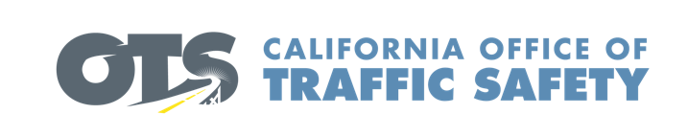

Add Agency Logo

For Immediate Release Enter Month and Day, 2023
Enter First Name, Last Name, Phone and Email

Enter Agency Name Awarded Grant from the Office of Traffic Safety for New Emergency Response Equipment

Enter Your City, Calif. – Enter Agency Name is the recipient of a $Enter dollar amount grant to purchase new extrication equipment. Known as the “jaws of life,” first responders use these specialized tools to safely rescue crash victims trapped inside a vehicle.

“This grant will have a significant impact on our ability to protect and serve our community, allowing us to respond even more effectively in times of crisis,” said Enter Agency Name, Rank, First name, Last name. “The funding will pay for modern rescue tools and provide training to first responders that is critical for the care of those injured in crashes.” Suggested quote. Feel free to use own words announcing importance of receiving grant funding and the goal of the grant program

Delays in providing care to crash victims impact the “golden hour” of survival, a core principle in the emergency medical services industry. Reducing the time it takes to get to the patient, treat what can be treated, and transport the patient to the hospital helps increase the chance for recovery.

Funding for this program was provided by a grant from the California Office of Traffic Safety, through the National Highway Traffic Safety Administration.


  

