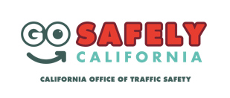
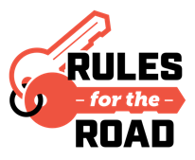
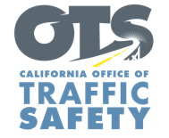
Add Agency Logo

FOR IMMEDIATE RELEASE
Enter Month and Day, 2023
Enter Name, Phone Number and Email Address

National Teen Driver Safety Week:
Parents Are Key to Keeping Teens Safe Behind the Wheel

Enter Your City Calif. – In recognition of National Teen Driver Safety Week (October 15-21), Enter Agency Name encourages teens and their parents to talk about the importance of always following the rules of the road and driving responsibly.

Car crashes remain the leading cause of death for teens (15-18 years old) in the United States. According to the National Highway Traffic Safety Administration (NHTSA), in 2021, an estimated 94,201 teen passengers were injured in car crashes and an estimated 170,083 people were injured in crashes involving a teen driver, accounting for almost 7% of all roadway injuries that year.
"Parents are the first and most influential driving instructors for their teens,” Agency Name Title First and Last name said. “During National Teen Driver Safety Week, we want to remind parents that they are key to keeping their teens safe behind the wheel. By actively engaging in conversations about safe driving and setting a positive example, parents can make a significant impact on their teenager's driving behavior."

Enter Agency Name offers the following tips to parents and guardians for starting conversations about safe driving with teens:
- Provisional Driver’s License : Learn about California’s provisional licensing law, which places restrictions on passengers and driving at night during the first year they have a license.
- Lead by example: Have driving sessions with your teen. Tell, but also show your teen how to drive safely.
- Set ground rules: Be firm on rules such as no phone use, eliminating distractions by friends, always following the speed limit, and always buckling up.
- Sober driving: Emphasize the importance of never driving under the influence or riding with someone who has been drinking.

Delete if not applicable Funding for this program was provided by a grant from the California Office of Traffic Safety, through the National Highway Traffic Safety Administration.
###

