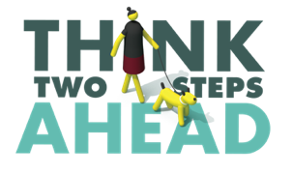
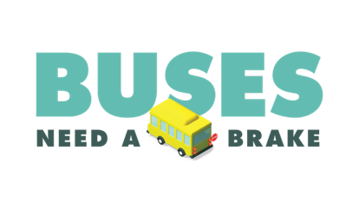
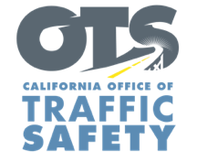

Add Your Agency Logo

For Immediate Release
Enter Month and Day, 2023
Enter First Name, Last Name, Email, Phone Number

National School Bus Safety Week Reminds Drivers:
Always Stop for School Buses to Protect Children

Enter Your City, Calif. – This National School Bus Safety Week (October 16-20), Enter Agency Name supports efforts to keep children and caregivers safe by reminding drivers of the dangers of passing a stopped school bus. Drivers must come to a complete stop when a school bus stop-arm is extended and the red lights are flashing.

Held annually during the third week of October, National School Bus Safety Week is a way for parents, children, teachers, bus drivers, school administrators and law enforcement to promote traveling to and from school by bus as a safe transportation option.

While riding the bus is the safest way for children to get to and from school, an alarming number of drivers illegally pass school buses who have their red lights activated. According to the National Highway Traffic Safety Administration (NHTSA), from 2000-2021, there were 53 deaths in crashes that involved a driver illegally passing a stopped school bus. Almost half of those deaths (25) were pedestrians 18 years old or younger.

Enforcement Only: delete if not applicable During National School Bus Safety Week, officers in plain clothes will work with uniformed officers to monitor crosswalks and areas surrounding the schools for drivers who do not yield for bicyclists or pedestrians, are speeding, or illegally passing a school bus. The enforcement period will run from Enter Start Date/Time to Enter End Date/Time.

With few exceptions, California law requires drivers to stop in both directions when a school bus has flashing red lights on. Drivers must stop until the red lights are off, and children are on or off the bus and safely out of the road.

"Safety on the road is a shared responsibility, and during National School Bus Safety Week, we must all be vigilant in protecting our children,” Enter Agency, Rank, First Name and Last name said. “Remember to stop for school buses, and together, we can make every journey to school a safer one."

Delete if not applicable Funding for this program was provided by a grant from the California Office of Traffic Safety, through the National Highway Traffic Safety Administration.
###

