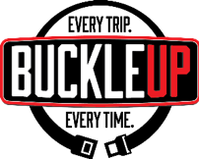
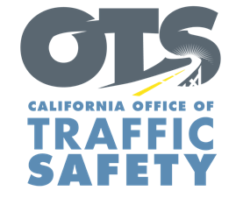

ADD AGENCY LOGO

FOR IMMEDIATE RELEASE: November Enter Day, 2022
CONTACT: Enter Name, Phone Number, E-mail address

Enter City or County Agency Encourages Everyone to Travel Safely and Make It to the Table for the Thanksgiving Holiday

Enter Your City, Calif. – As millions of families throughout the state hit the road to visit friends and family this Thanksgiving holiday, Enter City or County Agency reminds drivers and passengers the importance of wearing a seat belt, and the potentially deadly consequences of not buckling up.

Thanksgiving is one of the busiest travel times of the year. According to AAA, 54.6 million people are expected to travel 50 miles or more from home this Thanksgiving holiday, up 1.5% from 2021. With more cars on the road, the chances of being involved in a crash go up, and a seat belt is the best defense.

“Regardless of how far you are going for Thanksgiving, we want everyone to get to their destinations safely and enjoy the holiday,” Enter Title or rank first name last name said. “Wearing a seat belt is the single most effective thing you can do to protect yourself in the event of a crash. It’s critical that drivers and passengers buckle up, every trip, every time.”

During the 2020 Thanksgiving Maximum Enforcement Period, 33 people died on roadways within California Highway Patrol jurisdiction. Among those killed, 14 were not wearing seat belts.

Delete if not applicable During the Thanksgiving holiday Nov. 23-27 Enter Your Agency will conduct operations Enter any specific dates and times of operations specifically focused on drivers and passengers who are not wearing their seat belt, including children who are not secured in child safety seats.

Under California law, children under two years old who weigh under 40 pounds or are under 40 inches tall must ride in a rear-facing car seat. Children under the age of eight or under 4’ 9” tall must be secured in a car or booster seat.

Delete if not Applicable Funding for this program is provided by a grant from the California Office of Traffic Safety, through the National Highway Traffic Safety Administration.

###

