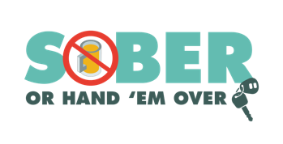
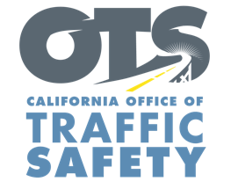
Enter Your Agency Logo
FOR IMMEDIATE RELEASE: November XX, 2022
Enter First Name, Last Name, Email and Phone Number

Plan Ahead This Holiday Season: Be Safe and Drive Sober

Enter City, Calif. – Millions of people will be traveling to visit friends and family over the holidays. The Enter Agency Name encourages everyone to celebrate safely and have a holiday game plan that includes a designated sober driver.

Delete if not applicable During the pre-Christmas and New Year’s holiday season Nov. 28-Dec. 13, Enter Agency Name will have additional officers on patrol looking for drivers suspected of driving under the influence of alcohol and/or drugs.

“We want everyone to enjoy the holidays and be safe,” said Enter Title or Rank, First and Last name said. “If you plan to go out and celebrate, make sure you plan ahead and find a safe, sober ride home because driving impaired should never be an option.”

Drunk driving is a problem on our nation’s roads every day, but it’s more prevalent during the holidays. During the 2016-2020 December months, there were more than 4,400 people killed in drunk-driving-related crashes.

Enter Agency Name reminds drivers that a “DUI Doesn’t Just Mean Booze.” Prescription medications, over-the-counter drugs and marijuana can also impair, especially in combination with alcohol and other drugs.

Delete if not applicable Funding for this program is provided by a grant from the California Office of Traffic Safety, through the National Highway Traffic Safety Administration.


  

