PRESS RELEASE

FOR IMMEDIATE RELEASE
Contact: Tim Weisberg
916-708-5128
Timothy.weisberg@ots.ca.gov

Office of Traffic Safety Celebrates Walk, Bike and Roll to School Day,
Highlights Importance of Safe Routes for Students to Take to Class

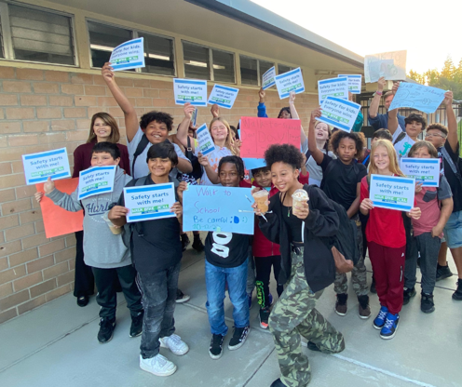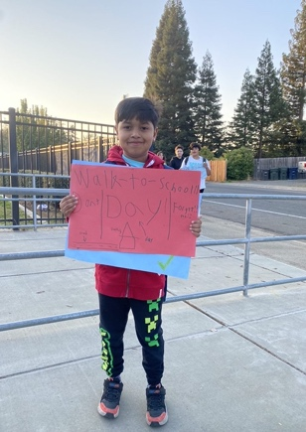

CITRUS HEIGHTS, Calif. – The California Office of Traffic Safety (OTS) joined students and school staff from Kingswood K-8 in Citrus Heights to celebrate the 26th annual Walk, Bike, and Roll to School Day. The national event highlights the health benefits of walking to school and the need for safe routes for students to walk and bike to school.
The OTS partnered with the Sacramento County Office of Education and Kingswood K-8 Club Live Program as participants carried signs while walking to campus, reminding drivers of their responsibility to stay alert for pedestrians, cyclists, and other vulnerable road users.
“Kids should feel comfortable and safe walking or riding a bike to class,” OTS Director Barbara Rooney said. “Pedestrians and bicyclists do not have the same protections as drivers and passengers. Drivers should slow down and drive like their niece, nephew, cousin, child, or sibling is walking or rolling to class.”
In 2020, 986 pedestrians were killed in California – nearly three pedestrians every day. Last year, pedestrian fatalities were projected to be up 13 percent nationwide compared to 2020. And in 2020, bicycle fatalities represented 3.4 percent of the total number of traffic fatalities. Most crashes are caused by drivers making improper turns, going unsafe speeds, and entering bicyclist and pedestrian right-of-way.
Kingswood K-8 is one of three schools benefitting from the San Juan Unified School District’s current Safe Routes to School program. The City of Citrus Heights received $30,000 in grant funds to implement the program as part of the Non-Infrastructure portion of the Mariposa Avenue Safe Routes to School project that completed the bicycle and pedestrian network in this area.
“Safe Routes to School has been a part of the San Juan Unified School District for over a decade,” said Natalee Dyudyuk, Community Safety Specialist for Safe Routes to School. “More than half of the SJUSD schools have benefited from education, encouragement, and evaluation of all surrounding active modes of transportation.”
The active transportation grant is part of more than $12 million in additional investments throughout the state from the federal Infrastructure Investment and Jobs Act (IIJA) to improve bike/walking safety around schools.

For more information about the SJUSD Safe Routes to School Program, visit www.sanjuan.edu/saferoutes.

# # #

About California Office of Traffic Safety
The California Office of Traffic Safety (OTS) administers traffic safety grants that deliver innovative programs and help to eliminate traffic fatalities and injuries on California roads. The OTS grant programs identify and address a variety of behavioral issues that impact traffic safety such as alcohol and drug-impaired driving, distracted driving, occupant protection, and bicycle and pedestrian safety. To learn more about the OTS, visit ots.ca.gov and gosafelyca.org. Follow us on Twitter and Instagram @OTS_CA and @GoSafelyCA, and on Facebook at www.facebook.com/CaliforniaOTS and www.facebook.com/GoSafelyCA.

