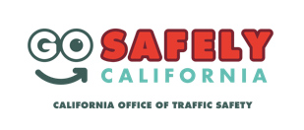
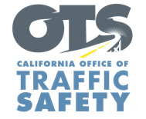
Add Agency Logo

FOR IMMEDIATE RELEASE
Enter Month and Day, 2022
Enter Name, Phone Number and Email Address

Enter Agency Name Reminds Parents Are Key to Keeping Teens Safe Behind the Wheel
National Teen Driver Safety Week kicks off October 16

Enter Your City Calif. – In recognition of National Teen Driver Safety Week (October 16-22), Enter Agency Name encourages teens and their parents to talk about the importance of following the rules of the road and driving responsibly.

Car crashes remain the leading cause of death for teens. According to the Insurance Institute for Highway Safety (IIHS), 2,378 teenagers died in car crashes in 2020 – a 14% increase from the prior year. Per mile driven, teen drivers are nearly four times as likely to be involved in a crash as drivers in all other age groups.

“Parents play a critical role in teen driver safety and in communicating important driving safety information,” Agency Name, Title, First and Last name said. “Teen drivers are still gaining experience behind the wheel and more likely to take risks and pick up bad habits. This is why it’s important for parents and caregivers to play an active role in talking to their teens about risky driving behaviors that can lead to deadly and tragic consequences.”

Enter Agency Name offers the following tips to parents and guardians for starting conversations about safe driving with teens:
- Provisional Driver’s License : Learn about California’s provisional licensing law, which places restrictions on passengers and driving at night during the first year they have a license.
- Lead by example: Have driving sessions with your teen. Tell, but also show your teen how to drive safely.
- Set ground rules: Be firm on rules such as no phone use, being distracted by friends, always following the speed limit, and always buckling up.
- Sober driving: Emphasize the importance of never driving under the influence or riding with someone who has been drinking.

Delete if not applicable Funding for this program was provided by a grant from the California Office of Traffic Safety, through the National Highway Traffic Safety Administration.
###

