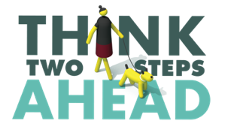
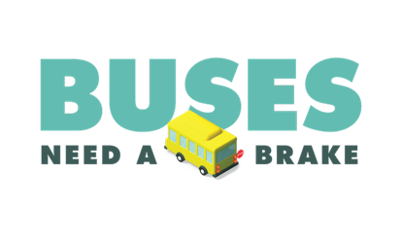
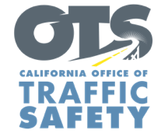

Add Your Agency Logo

For Immediate Release
Enter Month and Day, 2022
Enter First Name, Last Name, Email, Phone Number

Enter Agency Name Reminds Drivers to Always Stop for School Buses During National School Bus Safety Week

Enter Your City, Calif. – This National School Bus Safety Week (October 17-21), Enter Agency Name supports efforts throughout the state to keep children and caregivers safe by reminding drivers on the dangers of passing a stopped school bus. Drivers are required to come to a complete stop when a school bus stop-arm is extended, and the red lights are flashing.

Held annually during the third week of October, National School Bus Safety Week is a way for parents, children, teachers, bus drivers, school administrators and law enforcement to promote traveling to and from school by bus as a safe transportation option. This year’s campaign focuses on preventing illegal school bus passing.

While riding the bus is the safest way for children to get to and from school, an alarming number of drivers illegally pass school buses who have their red lights activated. From 2011 to 2020 a total of 218 school-age children (18 and younger) died in school-bus-related crashes during that period, either riding on school buses, other cars, or on foot or bike, according to the National Highway Traffic Safety Administration (NHTSA).

Enforcement Only: delete if not applicable During National School Bus Safety Week, officers in plain clothes will work with uniformed officers to monitor crosswalks and areas surrounding the schools for drivers who do not yield for bicyclists or pedestrians, are speeding, or illegally passing a school bus. The enforcement period will run from Enter Start Date/Time to Enter End Date/Time.

With few exceptions, California law requires drivers to stop in both directions when a school bus has flashing red lights on. Drivers must stop until the red lights are off, and children are on or off the bus and safely out of the road.

“It is so important that we remind drivers in our community that when red lights are flashing, there is no passing,” Enter Agency, Rank, First Name and Last name said. “Children and their caretakers are relying on drivers to follow the law and keep them safe.”

Delete if not applicable Funding for this program was provided by a grant from the California Office of Traffic Safety, through the National Highway Traffic Safety Administration.
###

