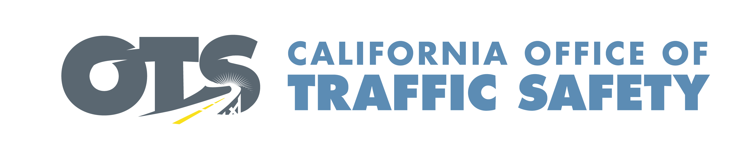

FOR IMMEDIATE RELEASE September Enter Date, 2022
Enter Contact First and Last Name
Enter Phone Number and Email

Child Passenger Safety Week is Sept. 18-24

Enter Your City, Calif. – During Child Passenger Safety Week, the Enter Your Organization Name will help parents and caregivers with installing child safety seats.

On Enter Specific Date and Time, Enter Your Organization Name will have certified child passenger safety technicians available at Enter Address to check car seat installations. The technicians will teach parents and caregivers how to install the car seat correctly, as well as educate them on the appropriate seat based on the child’s age and size. Delete paragraph if not applicable

“We are here to offer parents and caregivers guidance and reassurances that their child is as safe in a car seat as possible while riding in the car,” Enter Organization Name, Title, First and Last name said.

According to the National Highway Traffic Safety Administration (NHTSA), nearly half of car seats (46%) are misused.

Child Passenger Safety Week concludes with National Seat Check Saturday on Sept. 24. Enter Your Organization Name will be hosting a Car Seat Check event from Enter Time a.m. to p.m. or p.m. to p.m. at Enter Location in Enter City. Delete if not applicable.

California law requires all children under 2 years old to ride in a rear-facing car seat, unless the child is 40 or more pounds or is 40 or more inches tall. Parents are encouraged to keep your child in rear- and forward-facing seats as long as possible. Children 8 and older, who are at least 4 feet, 9 inches in height, may ride in the back seat of a vehicle in a properly fitted safety belt.

To learn more about the Enter Organization Name car seat program, Enter contact information including phone and email.

To search for car seat programs in your county, visit the OTS website. You may also contact your local CHP Area Office to schedule a free child safety seat inspection.

Delete if not applicable Funding for this program is provided by a grant from the California Office of Traffic Safety, through the National Highway Traffic Safety Administration.


  

