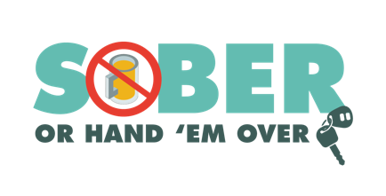
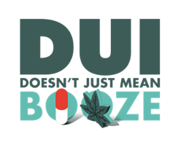
Enter Agency Letterhead

FOR IMMEDIATE RELEASE

Enter Month, Day and Year
Enter Contact First Name and Last Name
Enter Phone Number and Email

Enter Number Arrested for DUI During Late Summer, Labor Day Holiday

Your City, Calif. – Enter Your Police or Sheriff’s Department arrested Enter Number of Drivers drivers suspected of driving under the influence (DUI) during a nearly three-week period through Labor Day weekend.

The enforcement efforts were part of a national Drive Sober or Get Pulled Over mobilization campaign, where additional officers were on patrol throughout the country to take suspected impaired drivers off the road.

Among those arrested, Enter Number of Drivers were cited for driving under the influence of drugs and Enter Number of Drivers for a combination of alcohol and drugs. Delete section if no DUID arrests were made

In addition to patrols, Enter Your Police or Sheriff’s Department held a DUI checkpoint or Enter multiple dates if more than one checkpoint held on Enter Month and Day, leading to Enter Number of arrests DUI arrests. Delete paragraph if no checkpoints were held, or state “No DUI arrests were made.” If there were no arrests.

Most Californians consider drunk driving as one of their biggest traffic safety concerns, and drunk driving crashes accounted for 30 percent of all traffic deaths in the state in 2020.

First-time charges for DUI are an average of $13,500 in fines and penalties, which could include a suspended license.

Enter Police of Sheriff’s Department reminds the public that impaired driving is not just from alcohol. Marijuana, illicit drugs, even prescription and over-the-counter medications, may impair.

Funding for this program was provided by a grant from the California Office of Traffic Safety, through the National Highway Traffic Safety Administration. Delete if not applicable




