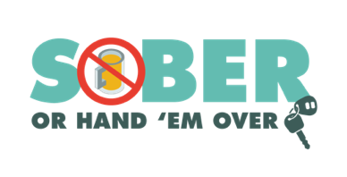
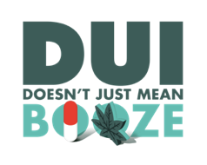
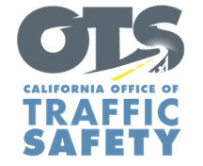
YOUR AGENCY LOGO

FOR IMMEDIATE RELEASE August XX, 2022
Enter Name, phone number and email address

Enter Your Agency Name Encourages Community to Choose a Sober Way to Travel

Enter your city, Calif. – As the summer travel season wraps up, Type Name of City Police or County Sheriff’s Department reminds drivers to be responsible and never drive under the influence of alcohol and/or drugs.

“Whether traveling locally or taking a longer road trip to see friends and family, please have a game plan for how to get home safely,” Enter Rank, First and Last Name of City Police or County Sheriff’s Department said. “There is never a good excuse for driving after drinking or using drugs that impair.”

Type Name of City Police or County Sheriff’s Department asks residents to take the necessary precautions to protect yourself and your family by buckling up, avoiding distractions behind the wheel, following the speed limit, and not driving impaired.

To help keep our community safe, the Enter Name of City Police or County Sheriff’s Department will have additional officers on patrol Aug. 17 through Labor Day (Sept. 5) looking for drivers suspected of driving under the influence of alcohol and/or drugs. The additional efforts to prevent impaired driving are part of a national enforcement campaign, Driver Sober or Get Pulled Over.

Delete if not applicable In addition to patrols, Type Name of City Police Department or County Sheriff’s Department will hold a DUI Checkpoint Type Month and Day or dates if holding multiple checkpoints from time in p.m. to time in a.m.at an undisclosed location within the city of Type name of city or county. Add specific location if allowed under department policy. Delete last two sentences if you do not disclose specific location of checkpoints.

In 2020, 1,159 people were killed throughout the state in drunk driving-related crashes, which accounted for 30 percent of all traffic deaths.

While drunk driving is a significant traffic safety problem, driving while impaired is not just from alcohol. Prescription drugs, over-the-counter medications and marijuana may also impair. If you plan on drinking or taking medications with a driving warning label, let someone who is sober drive. If you see someone driving impaired, call 9-1-1.

Funding for this program is provided by a grant from the California Office of Traffic Safety, through the National Highway Traffic Safety Administration. Delete this sentence if not applicable.
###

