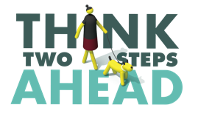
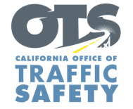
Add Agency Logo

FOR IMMEDIATE RELEASE Enter Month and Day, 2022
Enter Name, Phone Number and Email Address

Slow Down, Look Out for People Walking: September is Pedestrian Safety Month

Enter Your City, Calif. – September is Pedestrian Safety Month, and Enter Agency Name will participate in activities throughout the month encouraging the safety of people walking.

Based on data projections from the Governors Highway Safety Association (GHSA), 7,485 people, or an average of 20 people every day, died after being struck by a vehicle last year – an 11.5% increase from 2020 and a 40-year high.

“People should not feel in danger walking,” Enter Agency Name, Title, First and Last Name said. “Drivers, please slow down and be aware of people who are walking. If we all look out for one another, we can all get where we need to go safely.”

To promote the safety of people walking, Enter Agency name will Enter specific dates and details of safety events, including open streets. Delete if not applicable. Enforcement ONLY: conduct a traffic safety operation on (Month and Day) from (Enter time period) focused on the most dangerous driver behaviors that put the safety of pedestrians at risk. These violations include speeding, making illegal turns, failing to yield and running stop for signs or signals.

Enter Agency Name offers safe driving and walking tips, including staying off the phone when behind the wheel or walking:
Drivers
- Do not speed, and slow down at intersections. Be prepared to stop for pedestrians at marked and unmarked crosswalks.
- Avoid blocking crosswalks while waiting to make a right-hand turn.
- Never drive impaired.

Pedestrians
- Be predictable. Use signalized crosswalks where drivers may anticipate foot traffic.
- Watch for approaching vehicles and practice due care crossing the street. At 30 mph, a driver needs at least 90 feet to stop.
- Make it easier for drivers to see you at night – wear light colors, reflective material and use a flashlight.
- Be careful crossing streets or entering crosswalks at night or on busier streets with higher speed limits.

Delete if not Applicable Funding for this program is provided by a grant from the California Office of Traffic Safety, through the National Highway Traffic Safety Administration.



