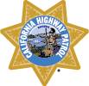
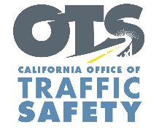
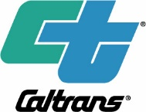
For Immediate Release
June 8, 2022
Contact:
Tim Weisberg
OTS Marketing and Public Affairs timothy.weisberg@ots.ca.gov
(916) 708-5128

Deadline for OTS and Caltrans’ ‘Get Off Your Apps’ video contest extended to July 4
Winners will get $2,500 for an iHeartMedia Music Festival Trip in Las Vegas and role in new PSA

Elk Grove, Calif. – The California Office of Traffic Safety (OTS) and California Department of Transportation (Caltrans) have extended the deadline for the ‘Get Off Your Apps’ distracted driving video contest to July 4.

OTS and Caltrans launched the contest April 15, asking California drivers to create a video saying and/or showing what they think is the best solution to end reckless and distracted driving, and what they do to not drive distracted. Winners will receive two tickets to the iHeartRadio Music Festival in Las Vegas, $2,500 for trip expenses and a role in a new television PSA being filmed this summer. Prizes will be provided courtesy of iHeartMedia.

Distracted driving is anything that takes one’s eyes, hands or mind away from the task of driving. In 2019, 3,142 people were killed nationwide in crashes involving a distracted driver, accounting for 8.7% of all traffic deaths. Mobile devices remain the biggest distraction for drivers, whether it is texting, talking, taking pictures, emailing, or using apps. A 2021 OTS Public Opinion Survey found 74.3% percent of Californians identified distracted driving (texting or talking) as their biggest traffic safety concern on California roadways.

“Most distracted driving related crashes are the result of preventable behaviors, and the goal behind this contest is to keep those dangerous behaviors top of mind for Californians,” said OTS Director, Barbara Rooney.

“Nearly a million crashes occur each year nationwide as a result of distracted driving,” said Caltrans Acting Director Steven Keck. “This contest is a great opportunity for Californians to share their outlook on distracted driving and how it can be prevented.”

For a complete list of rules and regulations, visit https://iheartmedia.jotform.com/sweeps/go-safely-ca-rules. To view information about distracted driving, click here. To learn about other helpful ways to stay safe on the go, visit www.gosafelyca.org

###

