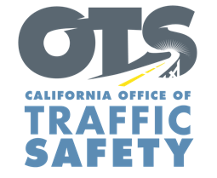
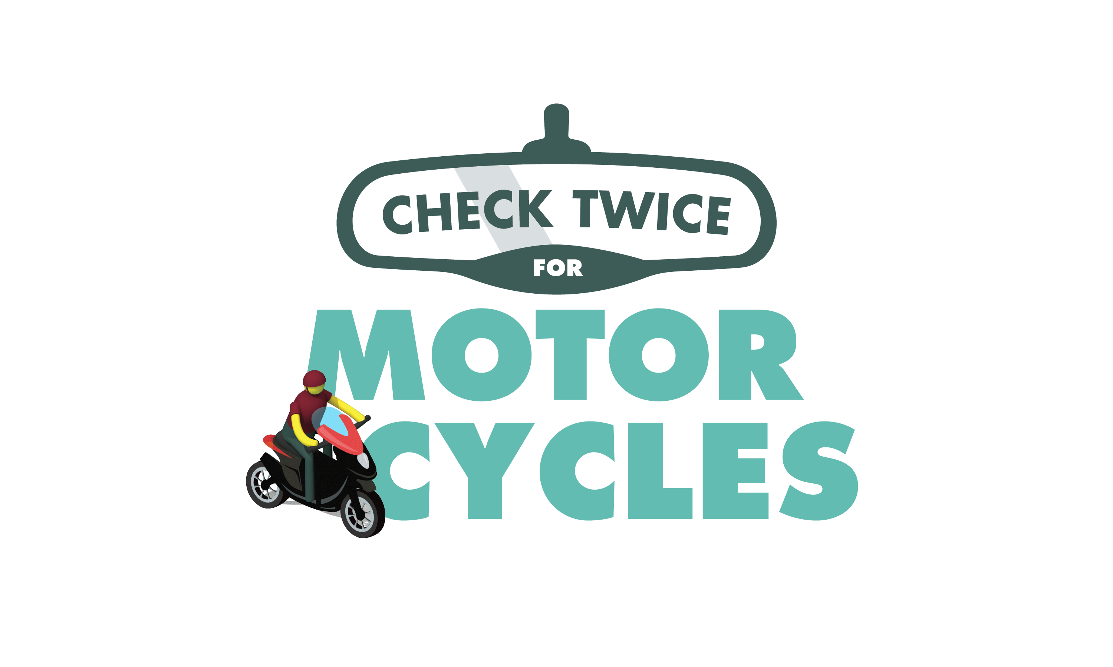

ENTER AGENCY LOGO

FOR IMMEDIATE RELEASE
Enter Month and Day, 2022
Enter First Name, Last Name, Email

Check Twice for Motorcycles: May is Motorcycle Safety Awareness Month

Enter Your City, Calif. — During May’s Motorcycle Safety Awareness Month, Enter Agency name reminds drivers to always look twice for motorcycles.

“Motorcycles may be difficult to spot, so being extra careful before changing lanes is always good practice,” Enter Title, First and Last name said. “Motorcycle riders are out in the elements and do not have the same protections drivers and passengers do. Please share the road with motorcycles and drive safe.”

Delete if not applicable Throughout the month, Enter agency details about education or enforcement programs

To help protect you and your family, keep the following tips in mind while driving or riding:

Drivers
- Always check mirrors and blind spots before changing lanes.
- Do not follow a motorcycle too closely. Always keep a safe distance.
- If you see a motorcycle with a signal on, be careful. Be sure that the rider is turning before moving ahead.
Motorcyclists
- Always wear a U.S. DOT-compliant helmet with eye protection.
- Wear leather or other sturdy clothing such as a jacket, pants, boots with nonskid soles and gloves. Add reflective strips or decals to your clothing and motorcycle to make it easier for other drivers to see you.
- Ride defensively. Don’t assume a driver can see you. Avoid riding in a driver’s blind spot.
- Always keep your lights on, even during the day.
Lastly, both drivers and riders should never drive/ride distracted under the influence of alcohol and/or drugs.

Delete if not applicable Funding for this program is provided by a grant from the California Office of Traffic Safety, through the National Highway Traffic Safety Administration.

  

