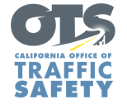
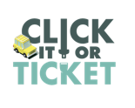

FOR IMMEDIATE RELEASE
Enter First Name, Last Name, Email, Phone Enter Month, Day, 2022

Californians Encouraged to Always Wear Their Seat Belt
“Click it or Ticket” Seat Belt Safety Campaign Runs Through Memorial Day

Enter Your City, Calif. – Enter Agency Name reminds everyone taking a trip to visit friends or family over the Memorial Day Weekend to always buckle up and keep children in child safety seats.

This year’s Click it or Ticket campaign is from May 23-June 5. During this time, the Enter Agency Name will have additional officers on patrol actively looking for drivers and passengers who are not wearing a seat belt. This includes vehicles where children are not secured in child safety seats.

“Wearing a seat belt should be an automatic for all drivers and passengers,” Agency Name, Title or Rank, First and last name said. “It’s the safe thing to do, especially when it comes to securing children in child safety seats.”

According to the National Highway Traffic Safety Administration (NHTSA), 10,893 people killed in crashes throughout the country in 2020 were not wearing seat belts. In California, 756 people killed in crashes in 2020 were not wearing seat belts, or nearly 20 percent of all traffic deaths in the state.

California law requires a child to be secured in a safety or booster seat until they are at least 8 or at least 4 feet, 9 inches tall. Children under the age of 2 must ride in a rear-facing seat unless the child weighs 40 or more pounds or is 40 or more inches tall.

California has a primary seat belt law, which allows law enforcement officers to ticket someone for not wearing a seat belt without committing another traffic violation.

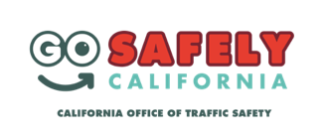
Delete if not applicable Funding for this program was provided by a grant from the California Office of Traffic Safety, through the National Highway Traffic Safety Administration.

###

