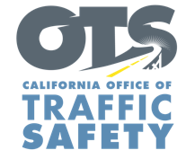

Add Agency Logo

For Immediate Release Enter Month and Day, 2022

Enter First Name, Last Name, Email, Phone

Enter County Name Probation Department Conducting DUI Offender Compliance Check

Enter Your City, Calif. –The Enter County Probation Department will conduct a series of visits Enter Month and Day with probationers convicted of driving under the influence (DUI) to make sure they are following court-ordered terms of their probation

“Our monitoring program helps probationers stay on track with treatment and other court-ordered measures,” Enter County Probation Department, Title, First and last name said. “Regular monitoring is necessary to steer probationers on the road to recovery.”
Suggested quote. Feel free to use own words announcing importance of compliance checks

The compliance checks are routine unannounced visits for those on supervised probation. Probation officers check homes and vehicles for any alcohol, drugs, and other paraphernalia to verify compliance with conditions of their probation.

Funding for this program was provided by a grant from the California Office of Traffic Safety, through the National Highway Traffic Safety Administration.
# # #

