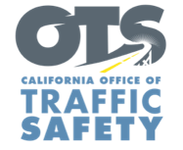
FOR IMMEDIATE RELEASE
Enter Month and Day, Year
Enter First Name, Last Name, Email

Enter Number Drivers, Motorcyclists Cited During
Motorcycle Safety Enforcement Operation

Enter Your City, Calif. – Enter Agency name cited Enter number drivers and motorcycle riders for a variety of violations.

During the operation Enter Month and Day from Enter time p.m. to p.m. or a.m. to p.m., Enter specific number for each citation (speeding, failure to yield, improper turn, DUI, etc.)

Enter Agency name will hold another motorcycle safety enforcement operation Enter Month and Day, delete sentence if not applicable.

Delete if not applicable Funding for this program was provided by a grant from the California Office of Traffic Safety, through the National Highway Traffic Safety Administration.

# # #

