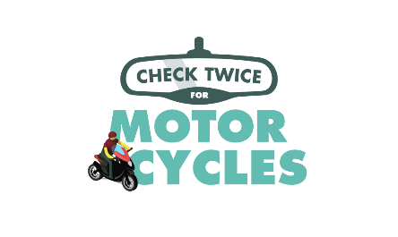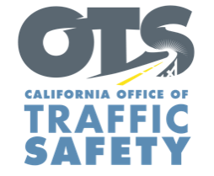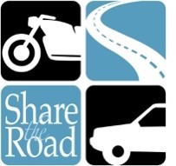
FOR IMMEDIATE RELEASE
Enter Month and Day, Year
Enter First Name, Last Name, Email

Enter Agency name Holding Motorcycle Safety Enforcement Operation Enter Month and Day

Enter Your City, Calif. – Enter Agency name will have extra officers on patrol Enter Month and Day from Enter time p.m. to p.m. or a.m. to p.m. looking specifically for violations made by drivers and motorcycle riders

The top primary crash factors for motorcycles are unsafe speed, improper turning, right-of-way violations, driving under the influence and unsafe lane changes. Speeding is the most common, accounting for nearly a third of all crashes in the state.

To help protect you and your family, keep the following tips in mind while driving or riding:
Drivers
- Always check twice for motorcycles in your mirrors and blind spots.
- Use your signal when changing lanes.
- Never follow a motorcycle too closely. Always keep a safe distance.
- When at an intersection, allow enough space before turning.
Motorcyclists
- Always wear a DOT compliant helmet and protective gear.
- Consider adding reflective tape to make it easier for other drivers to see you.
- Always keep your lights on, even during the day.
- Don’t assume drivers see you: signal well in advance before changing lanes and watch for turning vehicles.
- Although lane splitting is legal, the practice is not encouraged at high speeds in free-flowing traffic.
Enter Agency name will hold another motorcycle safety enforcement operation Enter Month and Day, delete sentence if not applicable.

Delete if not applicable Funding for this program is provided by a grant from the California Office of Traffic Safety, through the National Highway Traffic Safety Administration.
# # #

