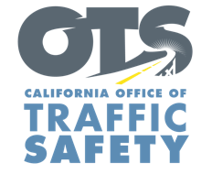
Enter Agency Logo

FOR IMMEDIATE RELEASE
Enter Month, Day, Year
Enter First Name, Last Name, Email, Phone Number

Enter Number Citations Issued For Hands-Free Cell Phone Violations

Enter Your City, Calif. – Enter number of drivers cited drivers were cited for hands-free cell phone violations during a distracted driving enforcement operation on Enter Date.

“Despite repeated efforts to warn drivers about the hands-free cell phone law, some drivers continue to use their phones while operating a vehicle,” Enter Name of Police/Sheriff’s Department Enter Rank, First Name, Last Name said. “Our ultimate goal is to change behaviors that help make our roads safer.”

California has had distracted driving laws on the books since 2008. Under current law, drivers are not allowed to hold their phone or other electronic device while driving. This includes talking, texting, or using an app.

Using a handheld cell phone while driving is punishable by a fine. Violating the hands-free law for a second time within 36 months of a prior conviction for the same offense will result in a point being added to a driver’s record.

If you have an important phone call or need to program directions, pull over to a safe parking spot. Before driving, either silence your phone or put it somewhere you can’t reach.

Funding for this program was provided by a grant from the California Office of Traffic Safety, through the National Highway Traffic Safety Administration.

###

