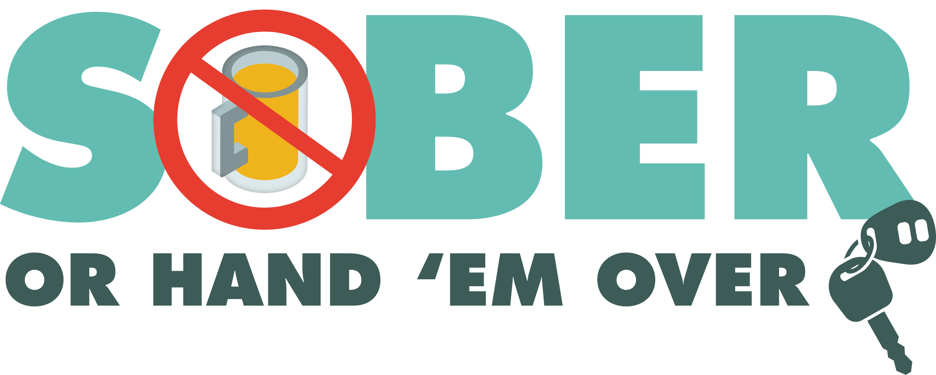
Enter Department Logo & Letterhead
For Immediate Release
Contact: Enter Name, Phone Number and Email

Enter Police/Sheriff’s Department Conducting DUI Patrols

Enter Your City, Calif. - The Enter Your Police/Sheriff’s Department will be out Enter Date from Enter time p.m. to time p.m./a.m. looking for drivers suspected of driving under the influence (DUI).

“Impaired driving is preventable,” Enter Rank or title, First Name, Last Name said. “It’s a choice. If you’ve been drinking or taken drugs that impair, make the right choice by finding a sober driver or alternate transportation to take you places.”

Enter Police of Sheriff’s Department reminds the public that impaired driving is not just from alcohol. Some prescription medications and over-the-counter drugs may interfere with driving. Always follow directions for use and read warning labels about driving. While medicinal and recreational marijuana are legal, driving under the influence of marijuana is illegal.

Drivers caught driving impaired and charged with a first-time DUI face an average of $13,500 in fines and penalties, as well as a suspended license.

Delete if not applicable Funding for this program was provided by a grant from the California Office of Traffic Safety, through the National Highway Traffic Safety Administration.

###

