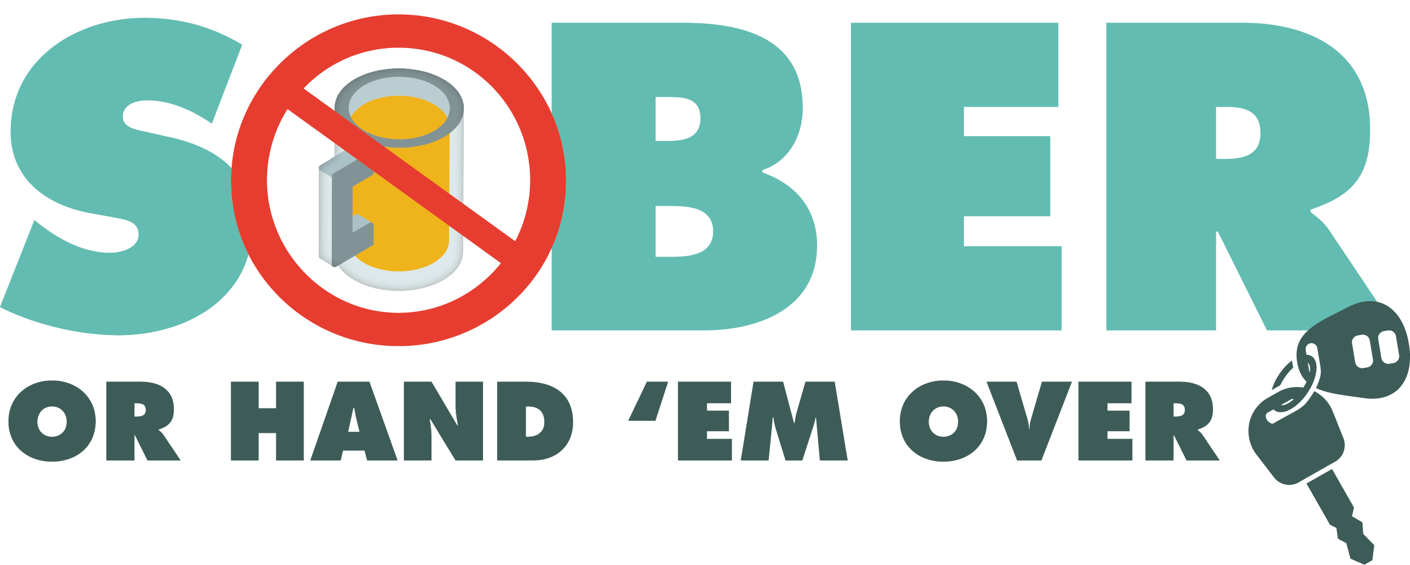
Enter Department Logo & Letterhead
For Immediate Release
Month and Date, 2022

Contact: Enter Name, Phone Number and Email

Enter Department Name Holding DUI Checkpoint Enter Month and Day

Enter Your City, Calif. – On Enter Date, the Enter Your Police/Sheriff’s Department will conduct a driving under the influence (DUI) Checkpoint Enter Month and Day from Enter time p.m. to Enter time p.m./a.m. at an undisclosed location or add location depending on Department policy. Delete this if not applicable.

DUI checkpoint locations are determined based on data showing incidents of impaired driving-related crashes. The primary purpose of DUI checkpoints are to promote public safety by taking suspected impaired drivers off the road.

“Impaired drivers put others on the road at significant risk,” Enter Rank or title, First Name, Last Name said. “Any prevention measures that reduce the number of impaired drivers on our roads significantly improves traffic safety.”

Enter Police of Sheriff’s Department reminds the public that impaired driving is not just from alcohol. Some prescription medications and over-the-counter drugs may interfere with driving. While medicinal and recreational marijuana are legal, driving under the influence of marijuana is illegal.

Drivers charged with a first-time DUI face an average of $13,500 in fines and penalties, as well as a suspended license.

Delete if not applicable Funding for this program was provided by a grant from the California Office of Traffic Safety, through the National Highway Traffic Safety Administration.

###

