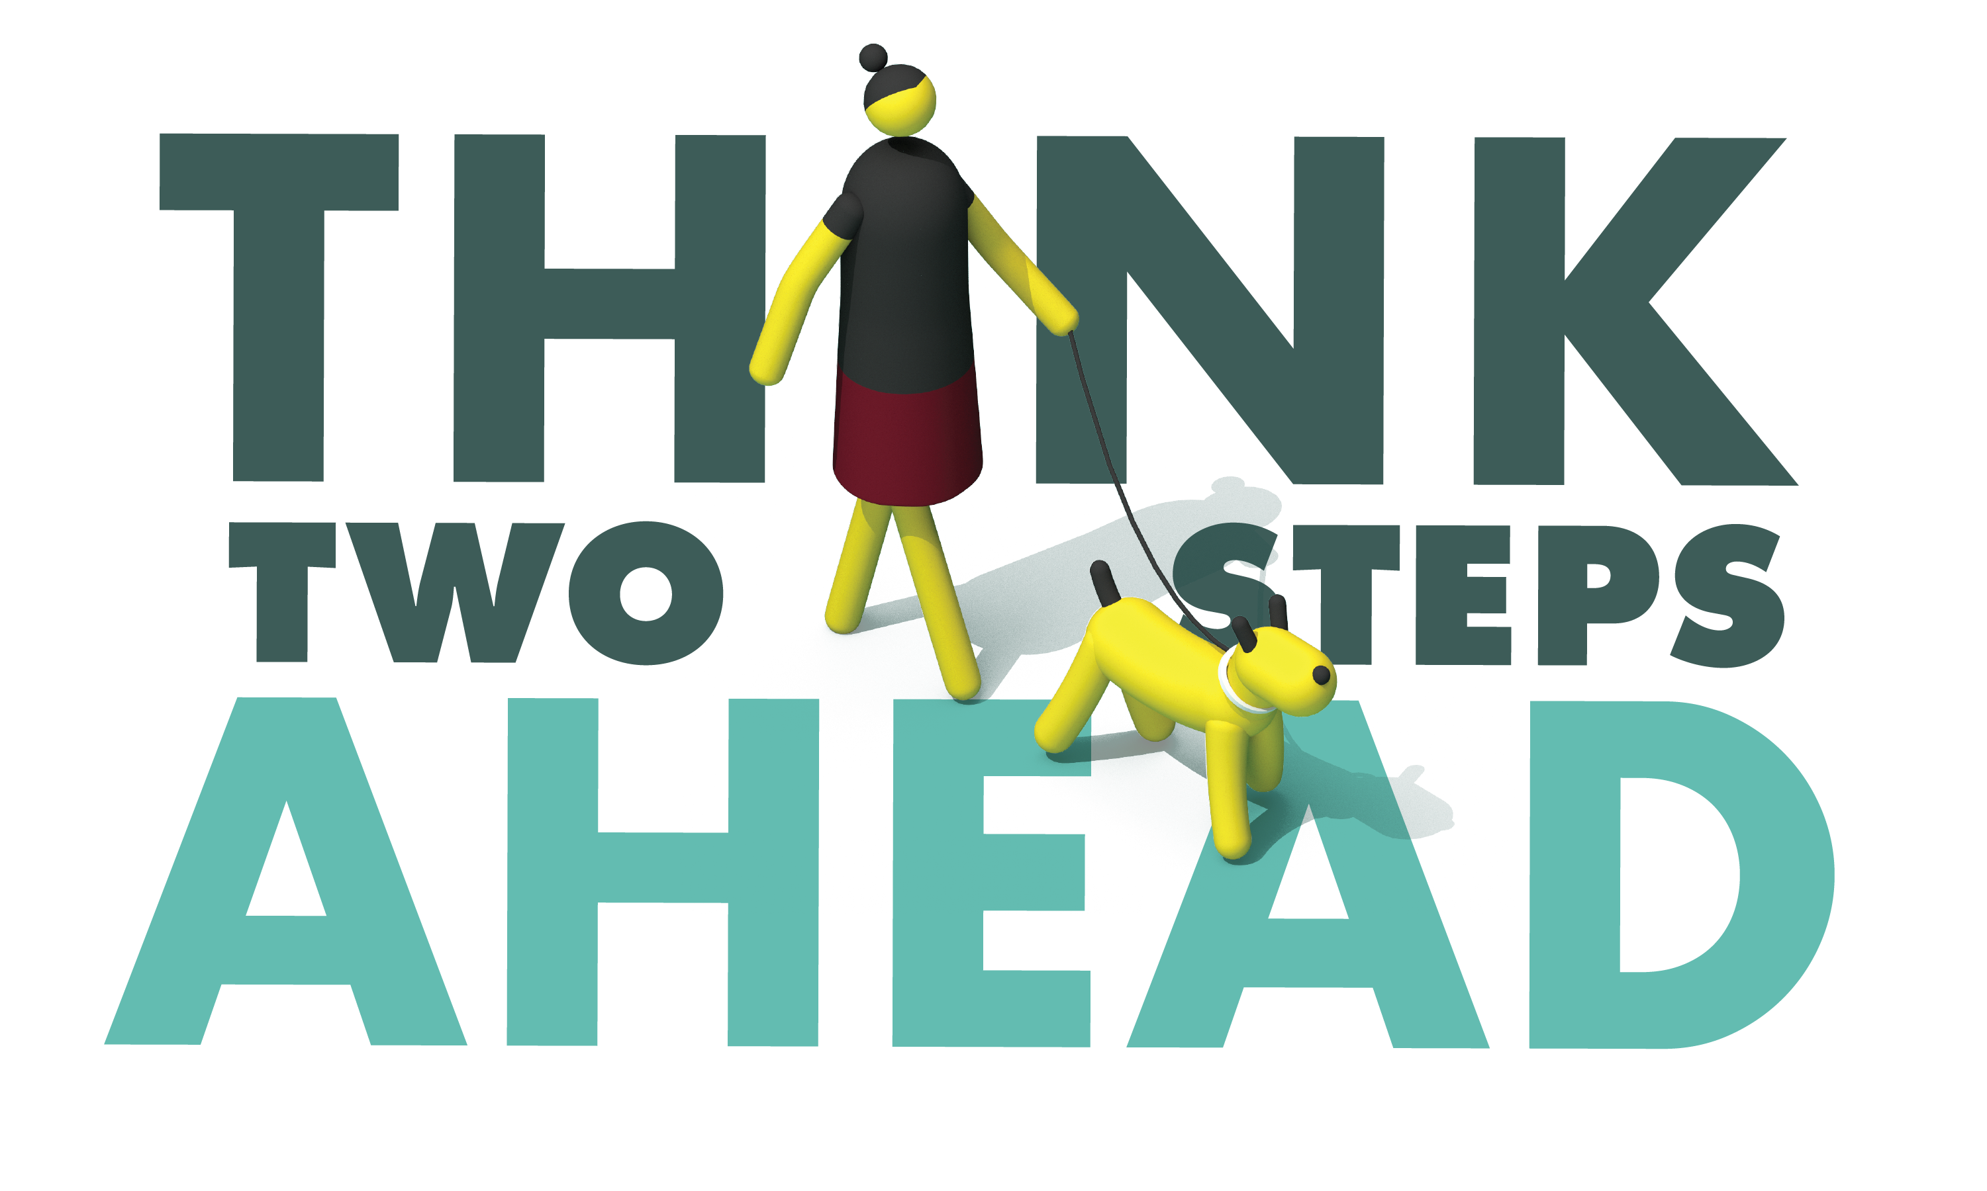
For Immediate Release
Enter Date First Name, Last Name, Email and Phone Number

Bicycle and Pedestrian Safety Operation Planned for Enter Month and Day

Enter City, Calif. – Enter Agency Name will conduct a traffic safety operation Enter date and time from a.m. to p.m. or p.m. to p.m. focused on the most dangerous driver behaviors that put the safety of people biking or walking at risk.

These violations include speeding, making illegal turns, failing to yield or provide right of way to bicyclists or pedestrians, or failing to stop for signs and signals.

“We all have places to be and not everyone gets there by car,” Enter Title or Rank, First and Last name said. “Bicyclists and pedestrians have the same rights to the road but face even more risk without the protections vehicles have. We should all be looking out for one another.”

The Enter Agency Name offers steps drivers and pedestrians can take to greatly reduce the risk of getting injured or in a crash:
Pedestrians
- Be predictable. Use crosswalks, when available.
- Take notice of approaching vehicles and practice due care.
- Do not walk or run into the path of a vehicle. At 30 mph, a driver needs at least 90 feet to stop.
- Be visible. Make it easy for drivers to see you – wear light colors, reflective material and carry a flashlight, particularly at dawn, dusk or at night.
- Be extra careful crossing streets or entering crosswalks at night when it is harder to see, or when crossing busier streets with more lanes and higher speed limits.
Drivers
- Follow the speed limit and slow down at intersections. Be prepared to stop for pedestrians at marked and unmarked crosswalks.
- Avoid blocking crosswalks while waiting to make a right-hand turn.
- Never drive impaired.
Bicyclists
- Obey traffic laws, use hand signals, use lights at night (front white light and rear red reflector), and wear a helmet.
- Bicyclists must travel in the same direction of traffic and have the same requirements as any slow-moving vehicle.
- Avoid the door zone: do not ride too closely to parked cars.
- If there’s a bike lane, use it, unless making a left turn, passing, or approaching a place where a right turn is allowed.
- Yield to pedestrians. Bicyclists must yield the right-of-way to pedestrians within marked crosswalks or within unmarked crosswalks at intersections.

Funding for this program is provided by a grant from the California Office of Traffic Safety, through the National Highway Traffic Safety Administration.

# # #

