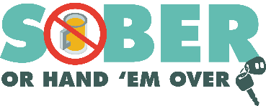
Agency logo/letterhead

FOR IMMEDIATE RELEASE

Enter Month, Day and Year
Enter Contact First Name and Last Name
Enter Phone Number and Email

Enjoy the Super Bowl Responsibly: Choose a Sober Way to Go

Your City, Calif. – The Enter Your Police or Sheriff’s Department is reminding football fans to stick to the “go safely” game plan and designate a sober driver if you plan on drinking at a Super Bowl LVI watch party.

On Super Bowl LVI Sunday (Feb. 13) If conducting DUI patrols on multiple days, say “During Super Bowl LVI weekend (Feb. 12 & 13), the Enter Your Police or Sheriff’s Department will have additional officers on patrol looking for drivers suspected of being under the influence of alcohol and/or drugs.

“If you plan to have a drink or two, choose a sober way to get to and from wherever you are watching the game,” Enter Rank or title, First Name, Last Name said. “Have a ride-hailing service or a family member who hasn’t been drinking take you home.”

Enter Police of Sheriff’s Department reminds the public that alcohol is not the only substance that impairs. Marijuana, prescription drugs, and over-the-counter medications can all affect your ability to drive safely. Do your research and understand the potential side effects of certain drugs.

“When it comes to getting to and from places safely, we’re all on the same team,” Enter Rank or title, First Name, Last Name. “The choice is simple: Don’t drive impaired.”

Delete if not applicable Funding for this program is provided by a grant from the California Office of Traffic Safety, through the National Highway Traffic Safety Administration.
###

